Lenin on the Enlightenment of the Proletariat
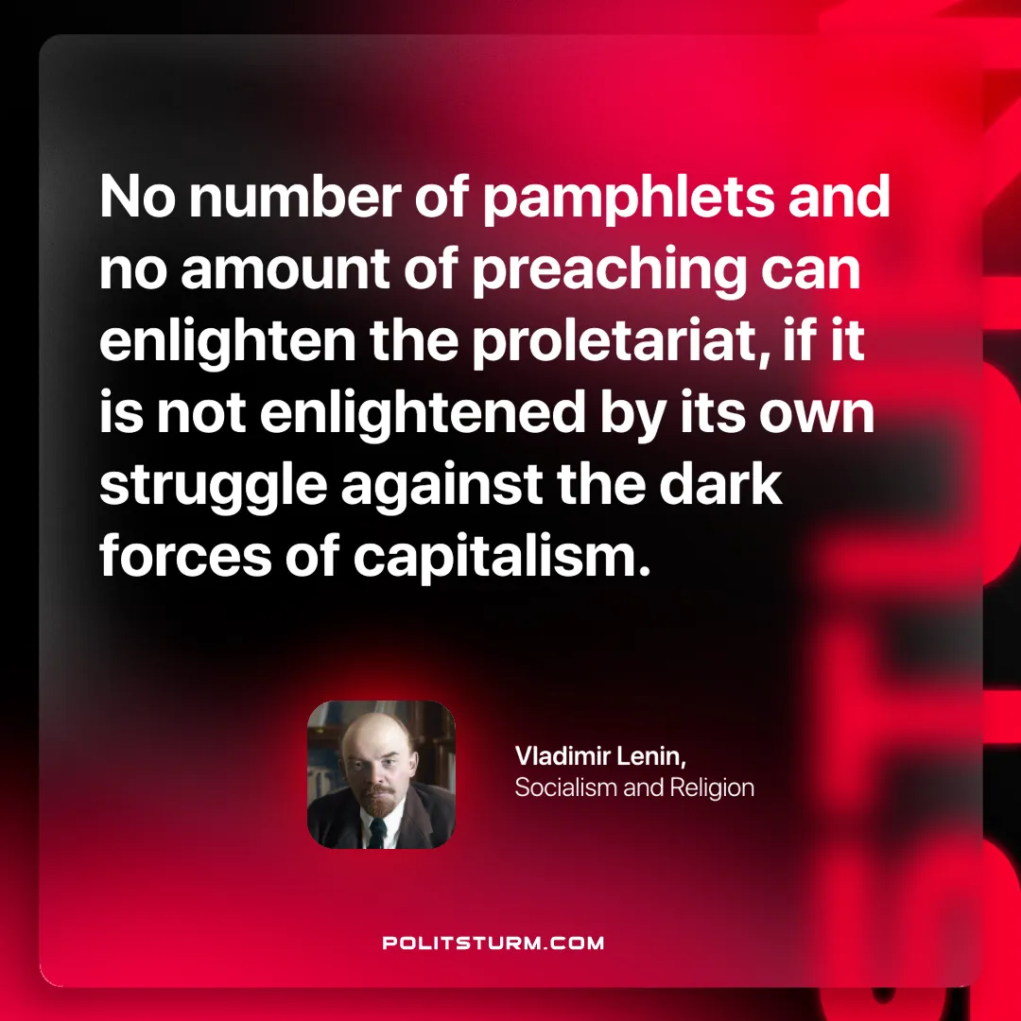

Original article
2024-10-27

“No number of pamphlets and no amount of preaching can enlighten the proletariat, if it is not enlightened by its own struggle against the dark forces of capitalism.”
Vladimir Lenin, Socialism and Religion

Original article

