Lenin on the End of the Wars
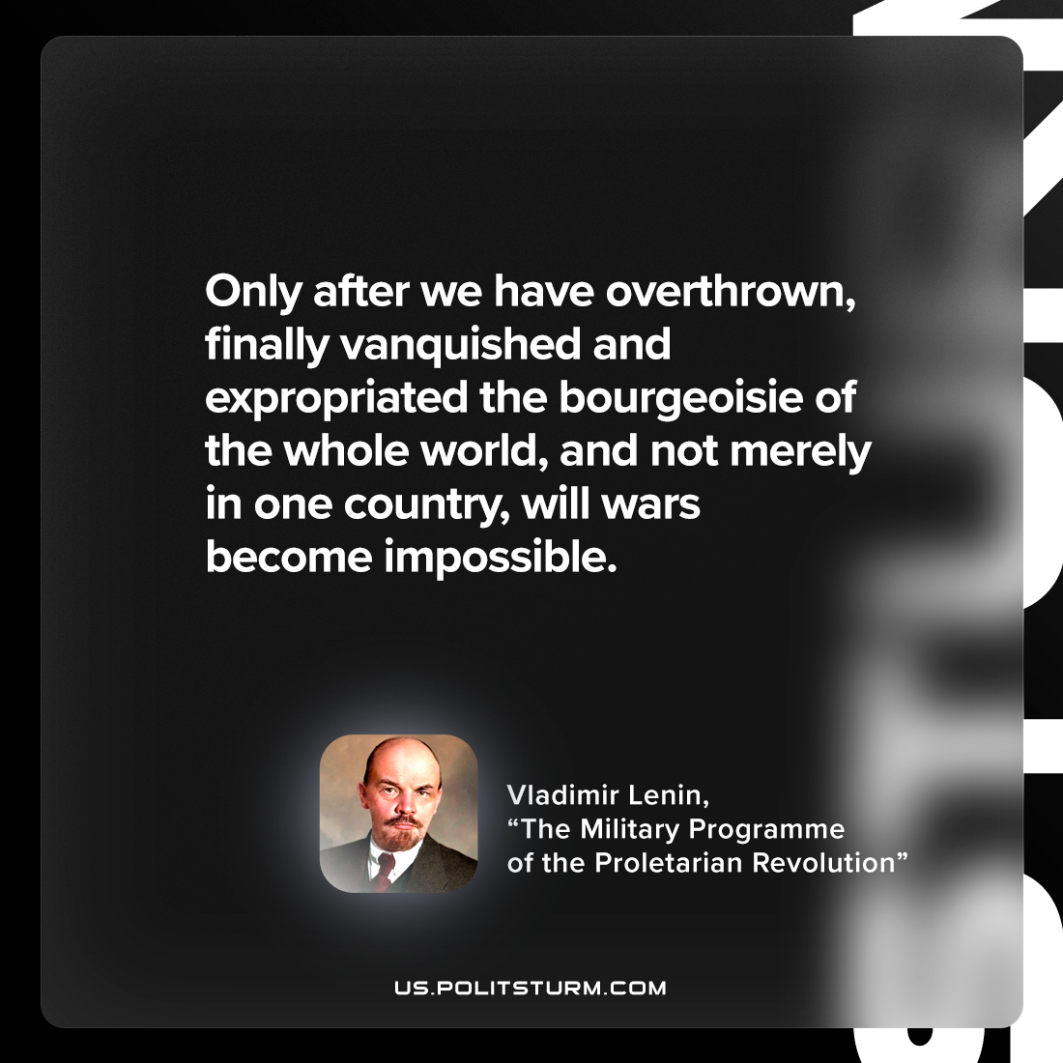

Original article
2023-01-24

"Only after we have overthrown, finally vanquished and expropriated the bourgeoisie of the whole world, and not merely in one country, will wars become impossible."
Vladimir Lenin, “The Military Programme of the Proletarian Revolution”

Original article

