Lenin on the End of Exploitation
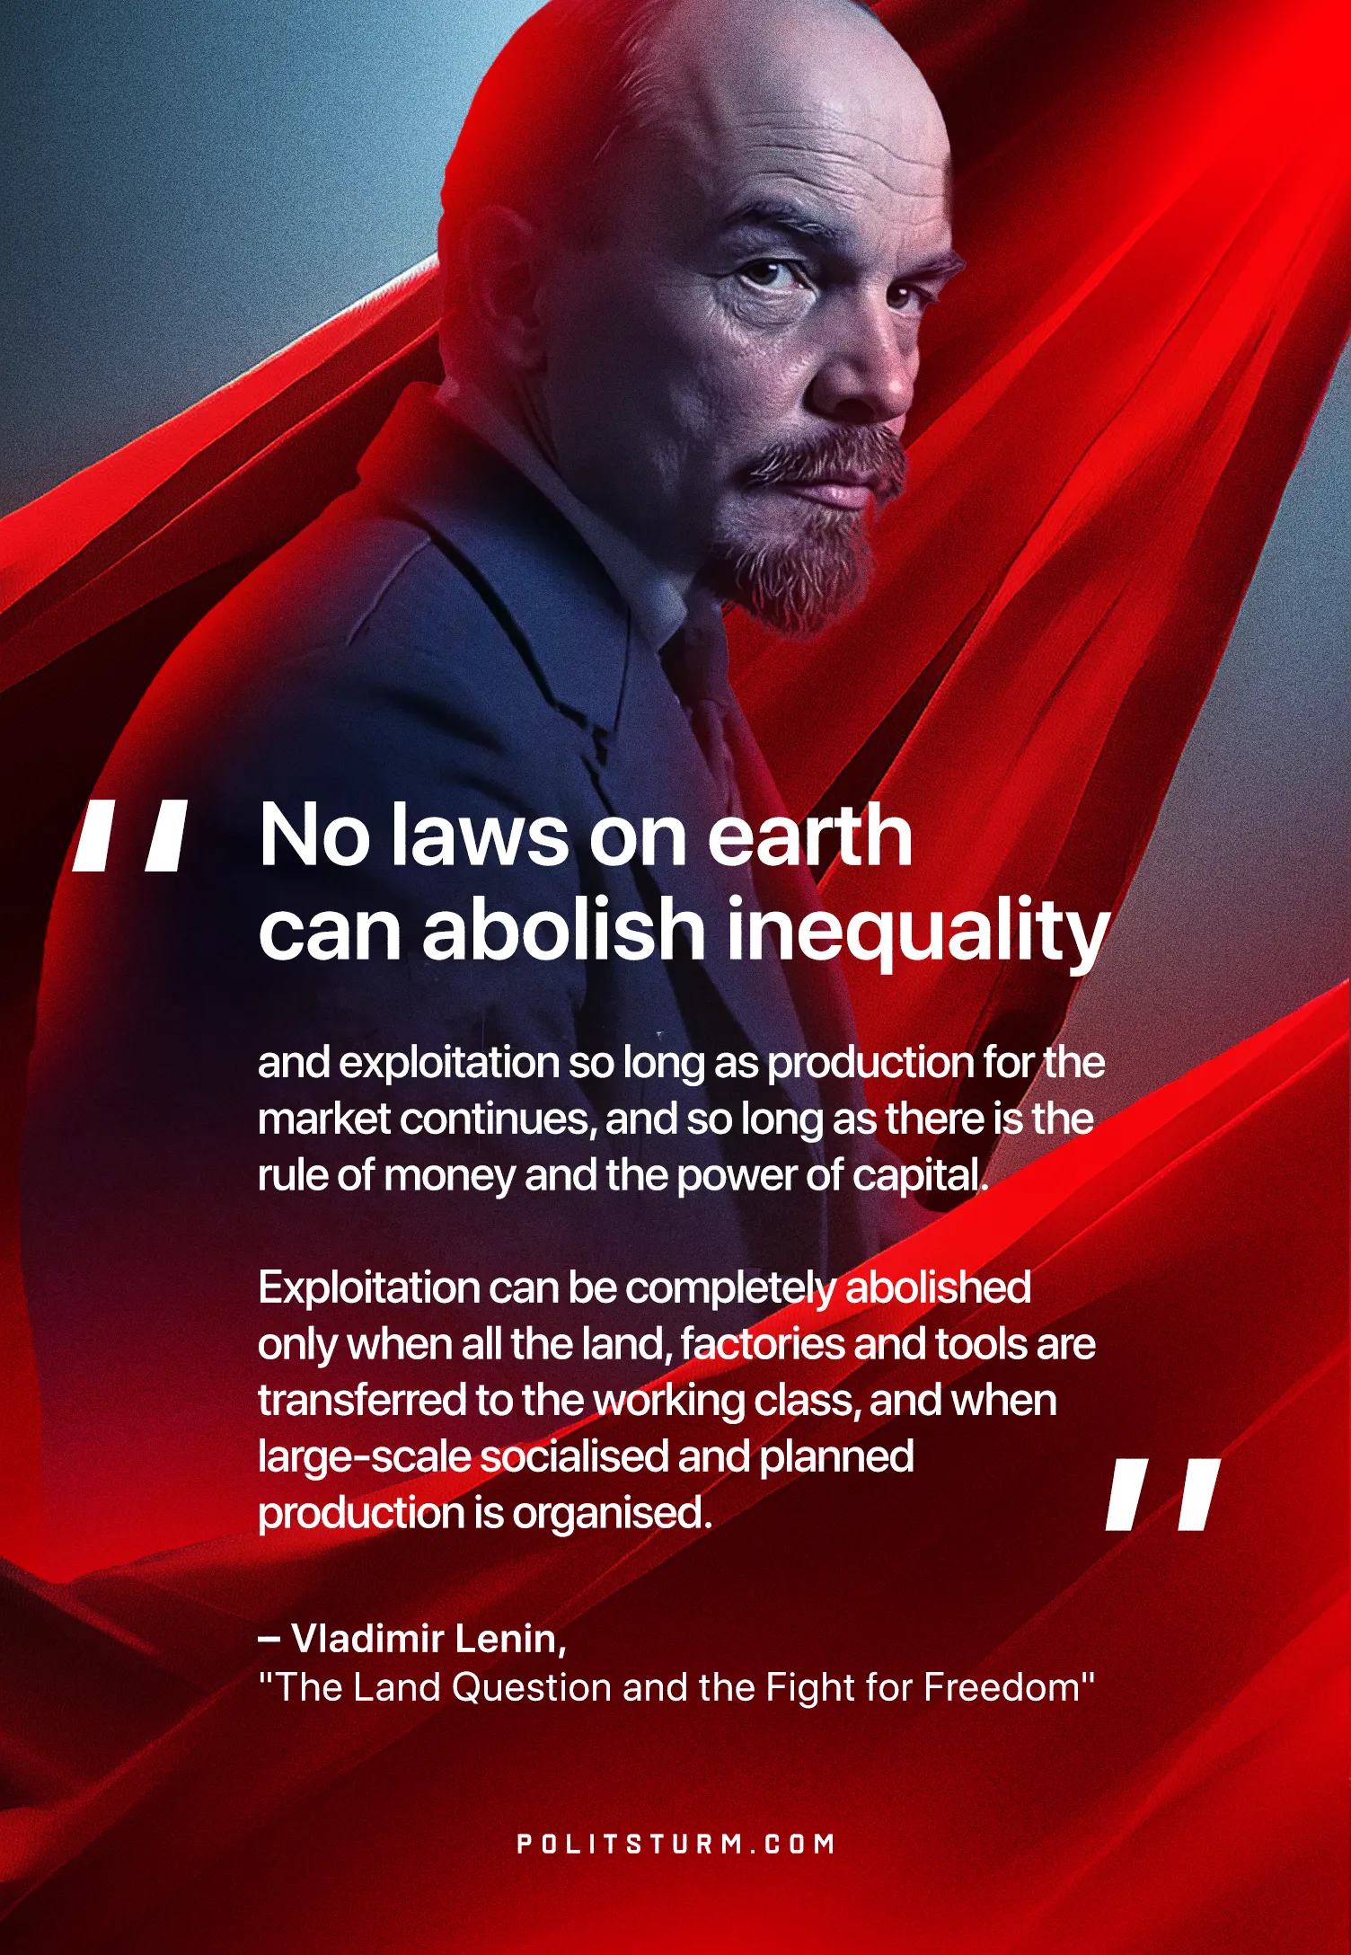

Original article
2025-05-17

"No laws on earth can abolish inequality and exploitation so long as production for the market continues, and so long as there is the rule of money and the power of capital. Exploitation can be completely abolished only when all the land, factories and tools are transferred to the working class, and when large-scale socialised and planned production is organised."
Vladimir Lenin, The Land Question and the Fight for Freedom

Original article

