Lenin on the Elimination of the Economic Foundations of Religion
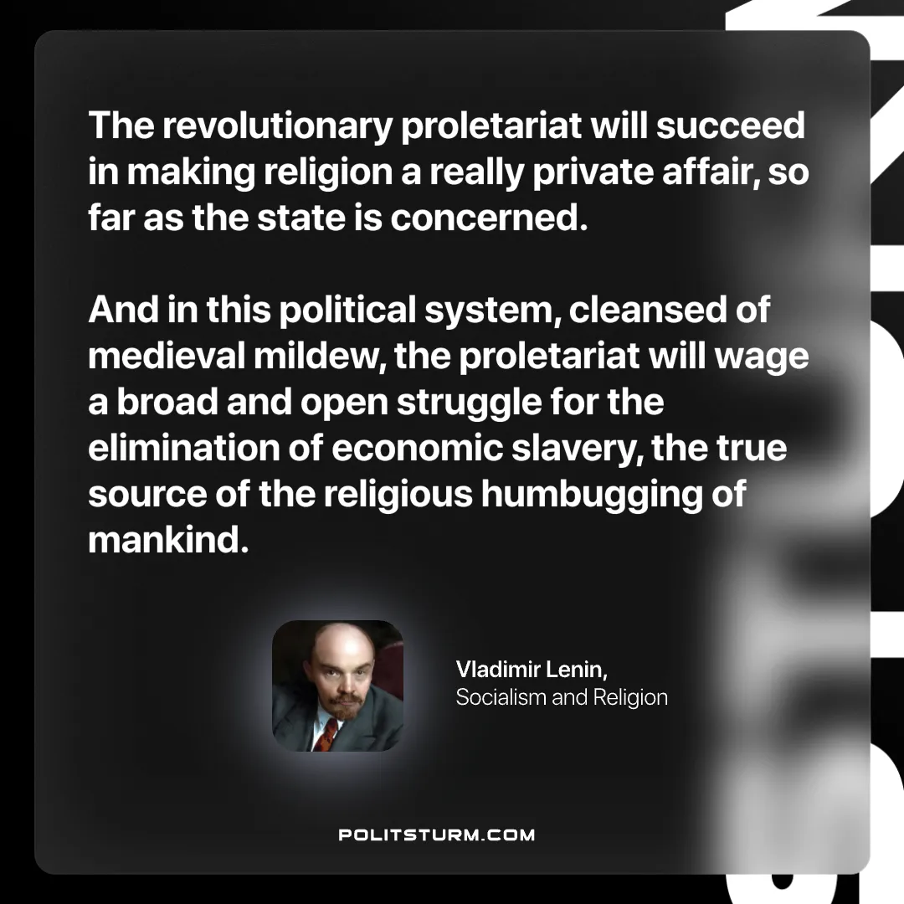

Original article
2025-01-28

“The revolutionary proletariat will succeed in making religion a really private affair, so far as the state is concerned. And in this political system, cleansed of medieval mildew, the proletariat will wage a broad and open struggle for the elimination of economic slavery, the true source of the religious humbugging of mankind.”
Vladimir Lenin, Socialism and Religion

Original article

