Lenin on the Education of the Masses
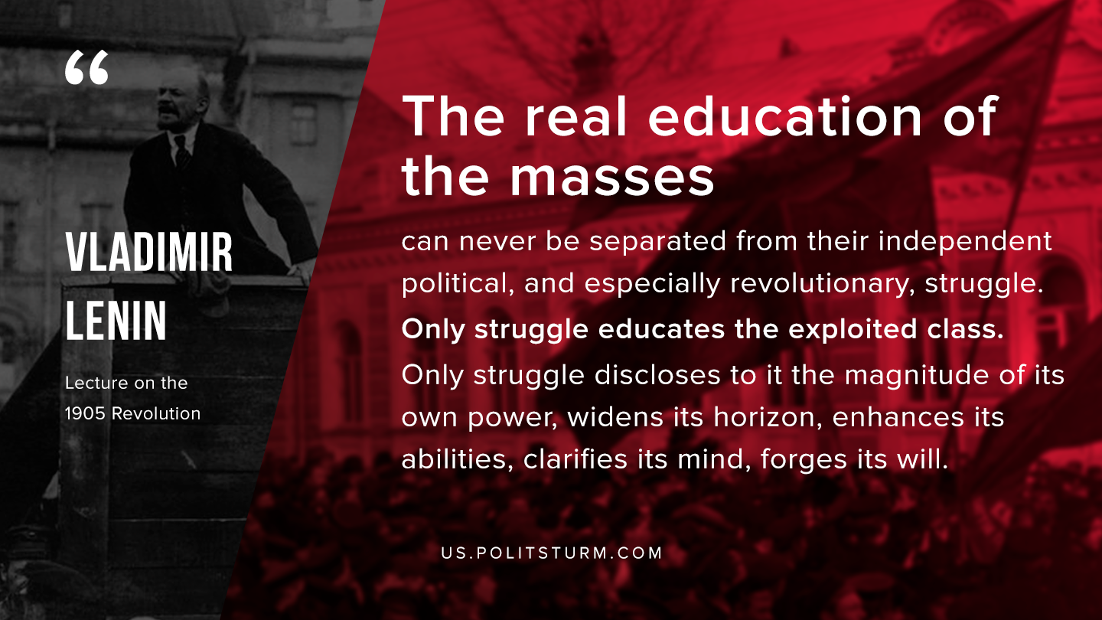

Original article
2019-11-22

The real education of the masses can never be separated from their independent political, and especially revolutionary, struggle. Only struggle educates the exploited class. Only struggle discloses to it the magnitude of its own power, widens its horizon, enhances its abilities, clarifies its mind, forges its will.
V.I. Lenin “Lecture on the 1905 Revolution”

Original article

