Lenin on the Economic Oppression
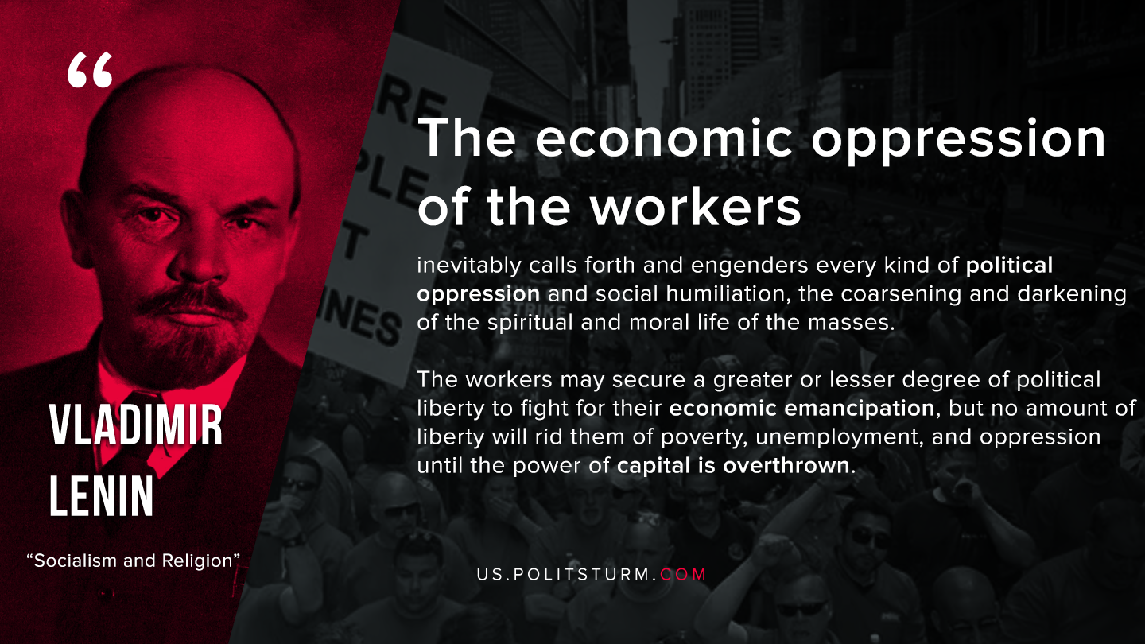

Original article
2020-06-01

The economic oppression of the workers inevitably calls forth and engenders every kind of political oppression and social humiliation, the coarsening and darkening of the spiritual and moral life of the masses. The workers may secure a greater or lesser degree of political liberty to fight for their economic emancipation, but no amount of liberty will rid them of poverty, unemployment, and oppression until the power of capital is overthrown.
V. I. Lenin
Socialism and Religion

Original article

