Lenin on the Economic Essence of Imperialism
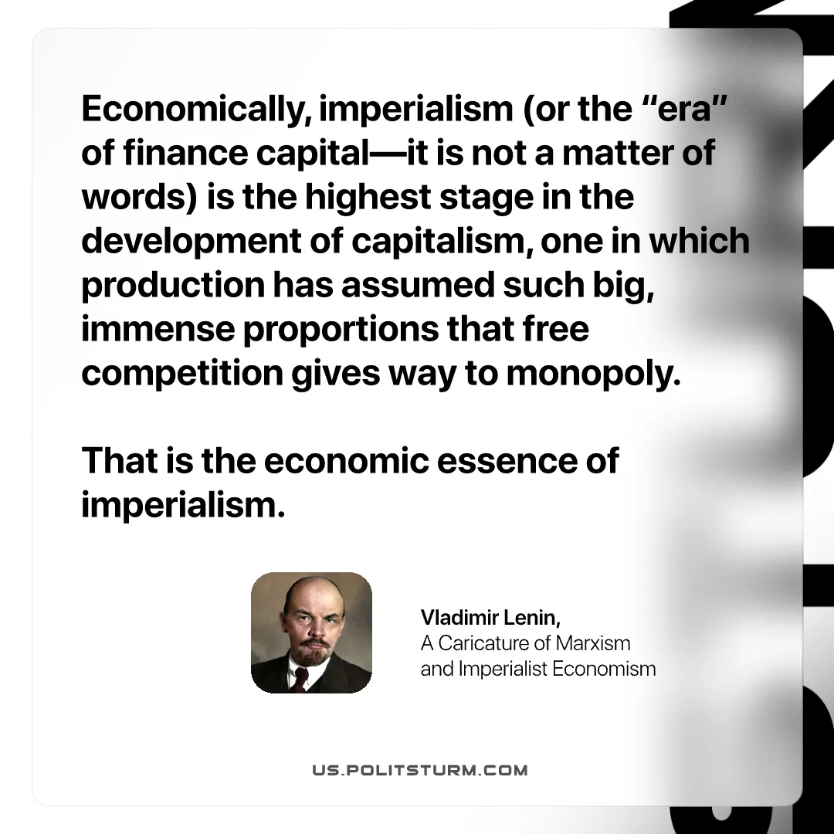

Original article
2025-08-07

“Economically, imperialism (or the “era” of finance capital—it is not a matter of words) is the highest stage in the development of capitalism, one in which production has assumed such big, immense proportions that free competition gives way to monopoly. That is the economic essence of imperialism.”
Vladimir Lenin, A Caricature of Marxism and Imperialist Economism

Original article

