Lenin on the Duty of the Proletariat to Push for Democracy
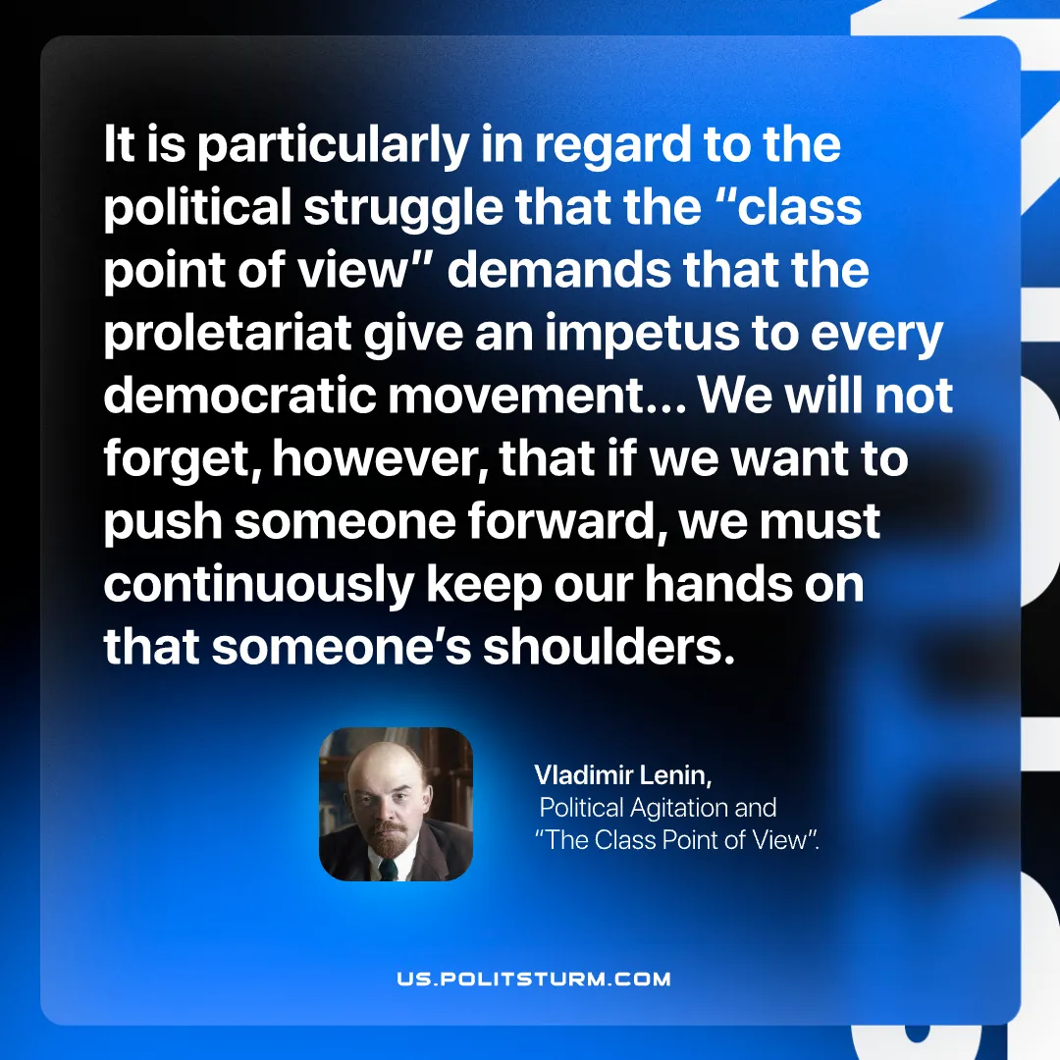

Original article
2026-06-27

It is particularly in regard to the political struggle that the “class point of view” demands that the proletariat give an impetus to every democratic movement… We will not forget, however, that if we want to push someone forward, we must continuously keep our hands on that someone’s shoulders.
Vladimir Lenin, Political Agitation and “The Class Point of View”.

Original article

