Lenin on the Dominant Culture of Capitalism
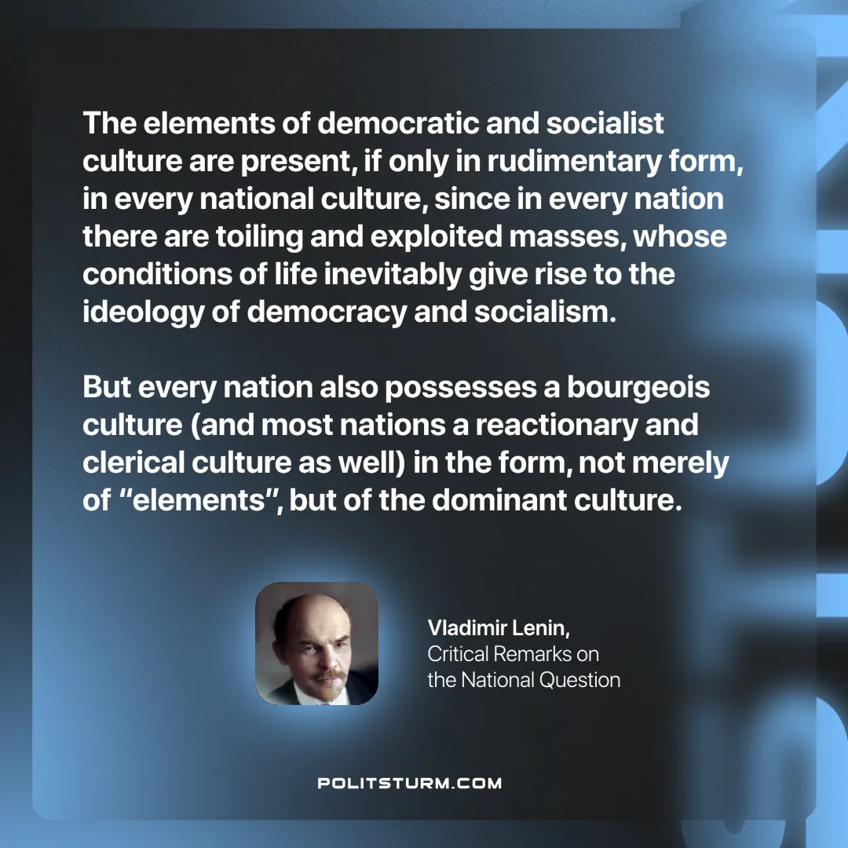

Original article
2024-10-29

“The elements of democratic and socialist culture are present, if only in rudimentary form, in every national culture, since in every nation there are toiling and exploited masses, whose conditions of life inevitably give rise to the ideology of democracy and socialism. But every nation also possesses a bourgeois culture (and most nations a reactionary and clerical culture as well) in the form, not merely of “elements”, but of the dominant culture.”
Vladimir Lenin, Critical Remarks on the National Question

Original article

