Lenin on the Division of the Masses
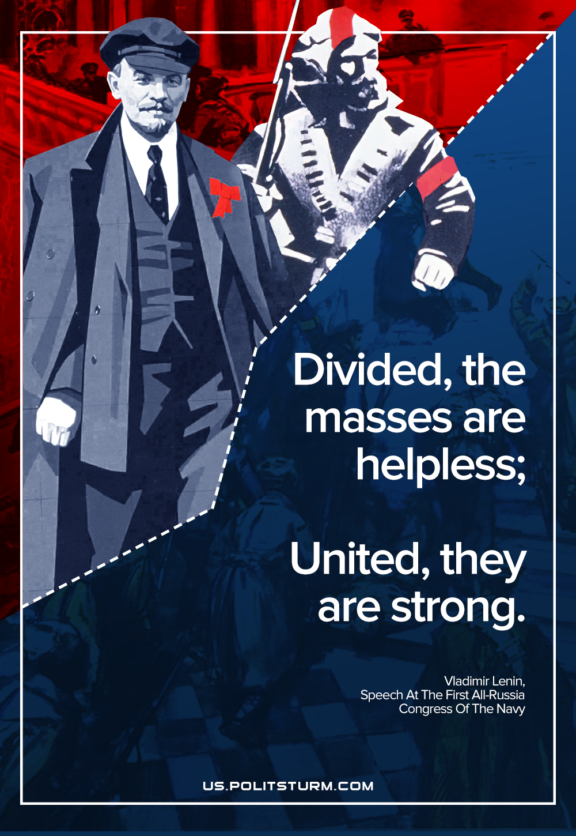

Original article
2021-09-01

Divided the masses are helpless; united they are strong.
Vladimir Lenin, “Speech At The First All-Russia Congress Of The Navy”

Original article

