Lenin on Those who Engage in Struggle and Those who Compromise
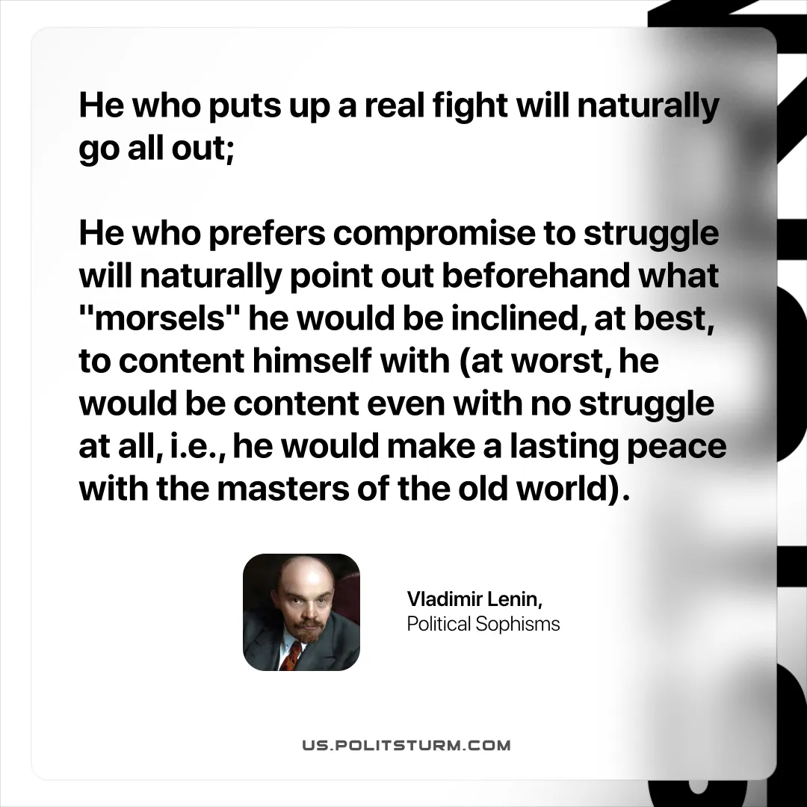

Original article
2025-10-07

“He who puts up a real fight will naturally go all out; he who prefers compromise to struggle will naturally point out beforehand what "morsels" he would be inclined, at best, to content himself with (at worst, he would be content even with no struggle at all, i.e., he would make a lasting peace with the masters of the old world)”
Vladimir Lenin, Political Sophisms

Original article

