Lenin on the Difference Between Capitalist and Proletarian Democracy
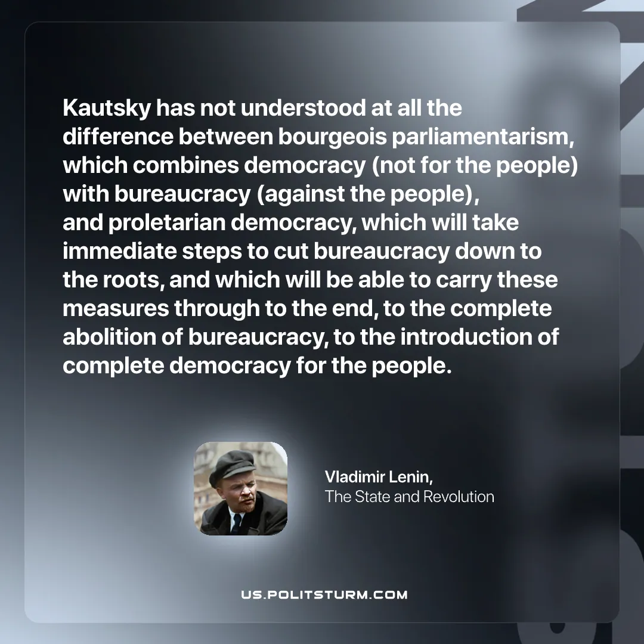

Original article
2025-09-06

“Kautsky has not understood at all the difference between bourgeois parliamentarism, which combines democracy (not for the people) with bureaucracy (against the people), and proletarian democracy, which will take immediate steps to cut bureaucracy down to the roots, and which will be able to carry these measures through to the end, to the complete abolition of bureaucracy, to the introduction of complete democracy for the people.”
Vladimir Lenin, The State and Revolution

Original article

