Lenin on the Dictatorship of the Proletariat
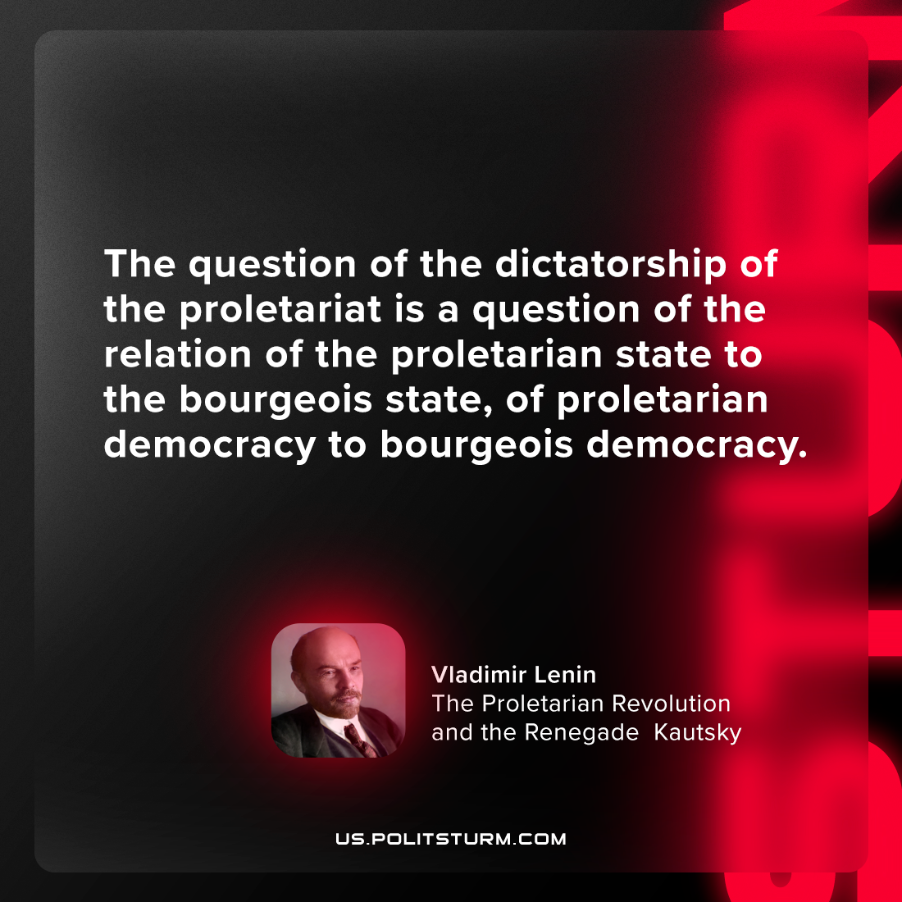

Original article
2024-02-29

"The question of the dictatorship of the proletariat is a question of the relation of the proletarian state to the bourgeois state, of proletarian democracy to bourgeois democracy."
Vladimir Lenin, The Proletarian Revolution and the Renegade Kautsky

Original article

