Lenin on the Dictatorship of the Proletariat
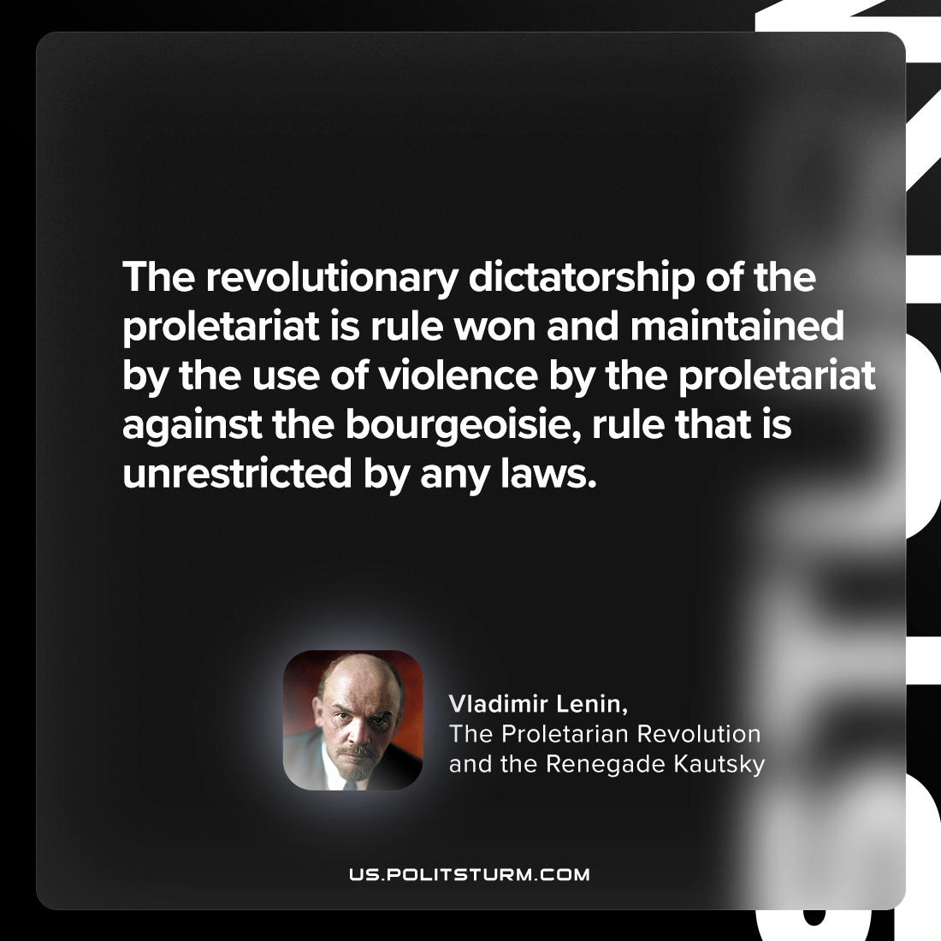

Original article
2024-06-13

"The revolutionary dictatorship of the proletariat is rule won and maintained by the use of violence by the proletariat against the bourgeoisie, rule that is unrestricted by any laws."
Vladimir Lenin, The Proletarian Revolution and the Renegade Kautsky

Original article

