Lenin on the Development and Hierarchy of Monopolies
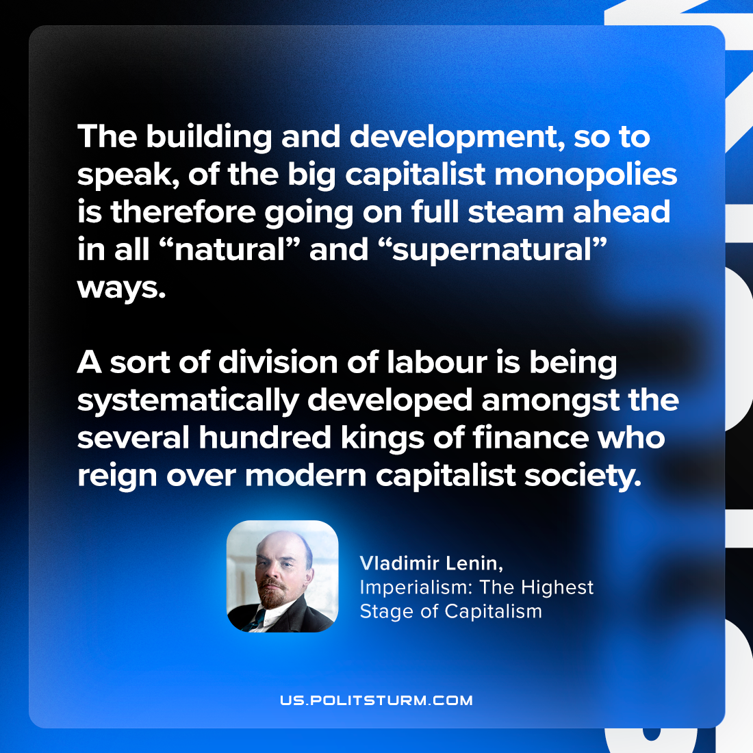

Original article
2023-09-26

"The building and development, so to speak, of the big capitalist monopolies is therefore going on full steam ahead in all “natural” and “supernatural” ways. A sort of division of labour is being systematically developed amongst the several hundred kings of finance who reign over modern capitalist society."
Vladimir Lenin, Imperialism: the Highest Stage of Capitalism

Original article

