Lenin on the Deception of the Workers by Nationalist and Peace Slogans
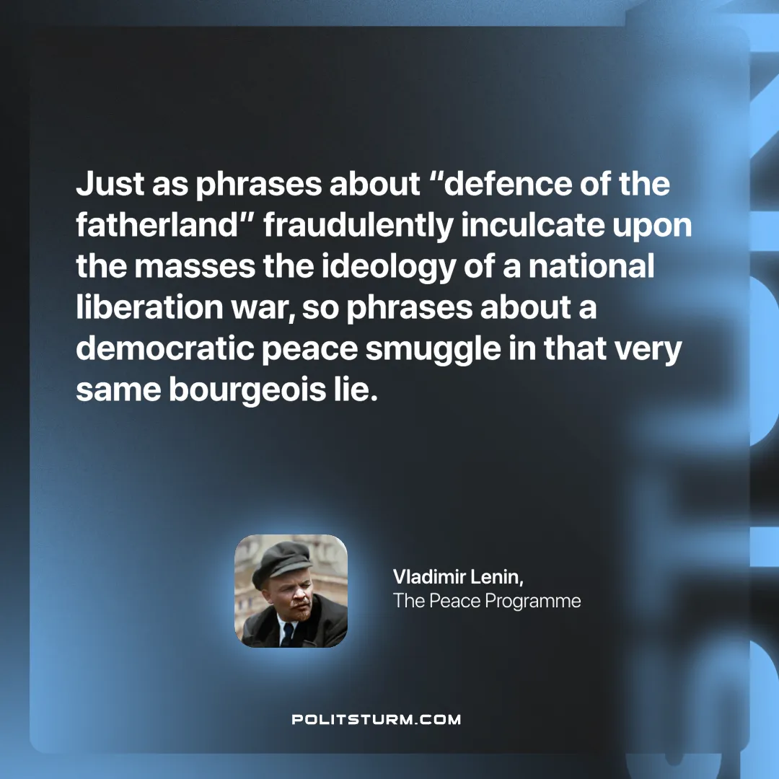

Original article
2025-05-22

“Just as phrases about “defence of the fatherland” fraudulently inculcate upon the masses the ideology of a national liberation war, so phrases about a democratic peace smuggle in that very same bourgeois lie.”
Vladimir Lenin, The Peace Programme

Original article

