Lenin on the Deception of Reforms
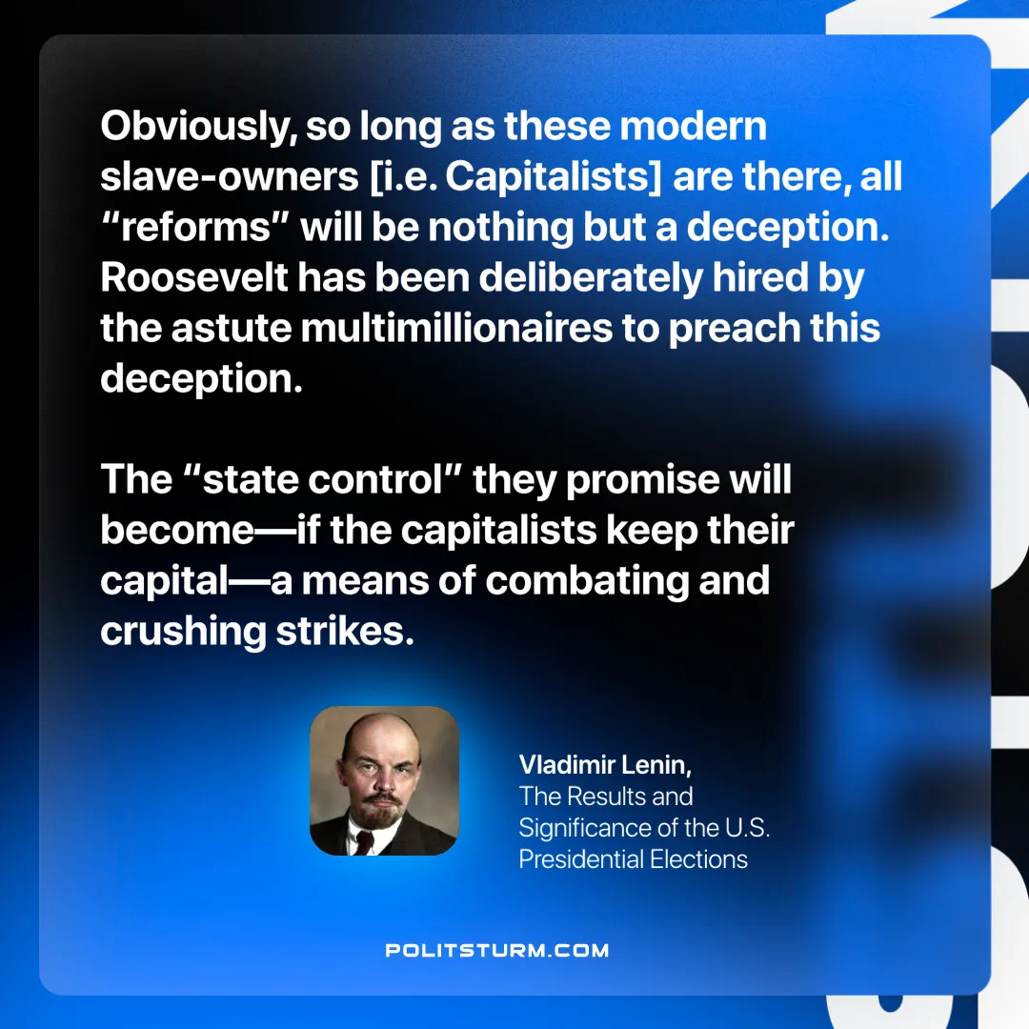

Original article
2025-03-22

“Obviously, so long as these modern slave-owners [i.e. Capitalists] are there, all “reforms” will be nothing but a deception. Roosevelt has been deliberately hired by the astute multimillionaires to preach this deception. The “state control” they promise will become—if the capitalists keep their capital—a means of combating and crushing strikes.”
Vladimir Lenin, The Results and Significance of the U.S. Presidential Elections

Original article

