Lenin on the Deceived Proletariat
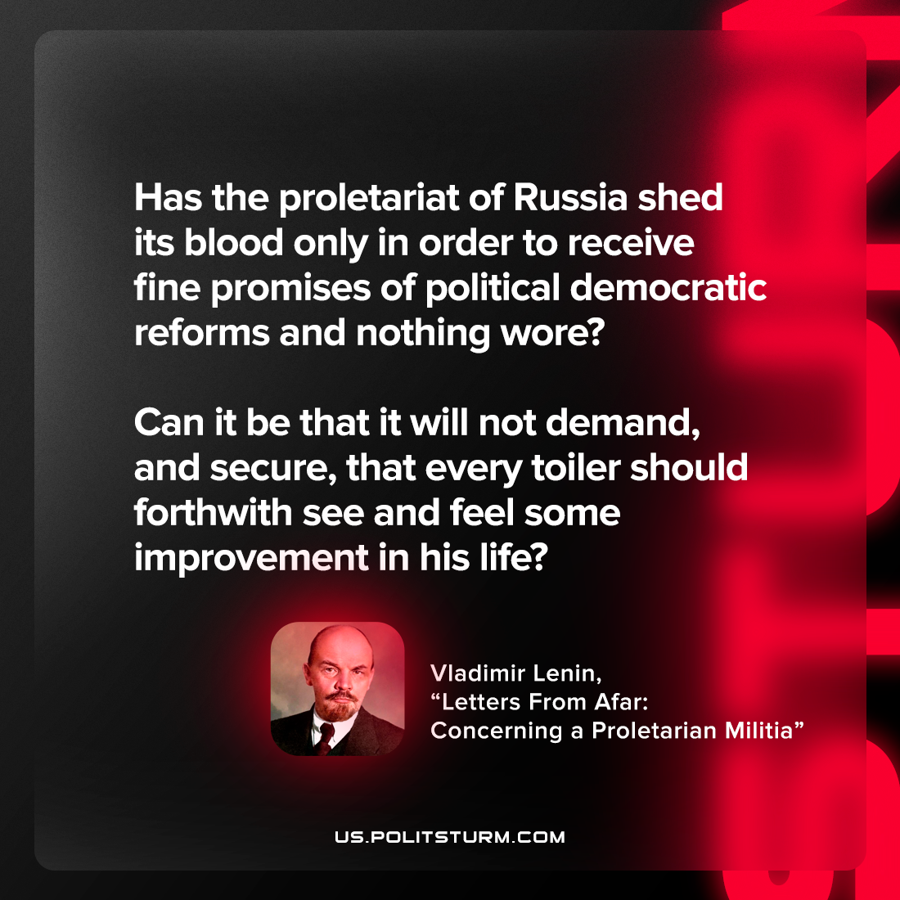

Original article
2022-09-05

Has the proletariat of Russia shed its blood only in order to receive fine promises of political democratic reforms and nothing wore? Can it be that it will not demand, and secure, that every toiler should forthwith see and feel some improvement in his life?

Vladimir Lenin, “Letters From Afar: Concerning a Proletarian Militia”

Original article

