Lenin on the Conversion of the Proletarian Struggle into a National Struggle
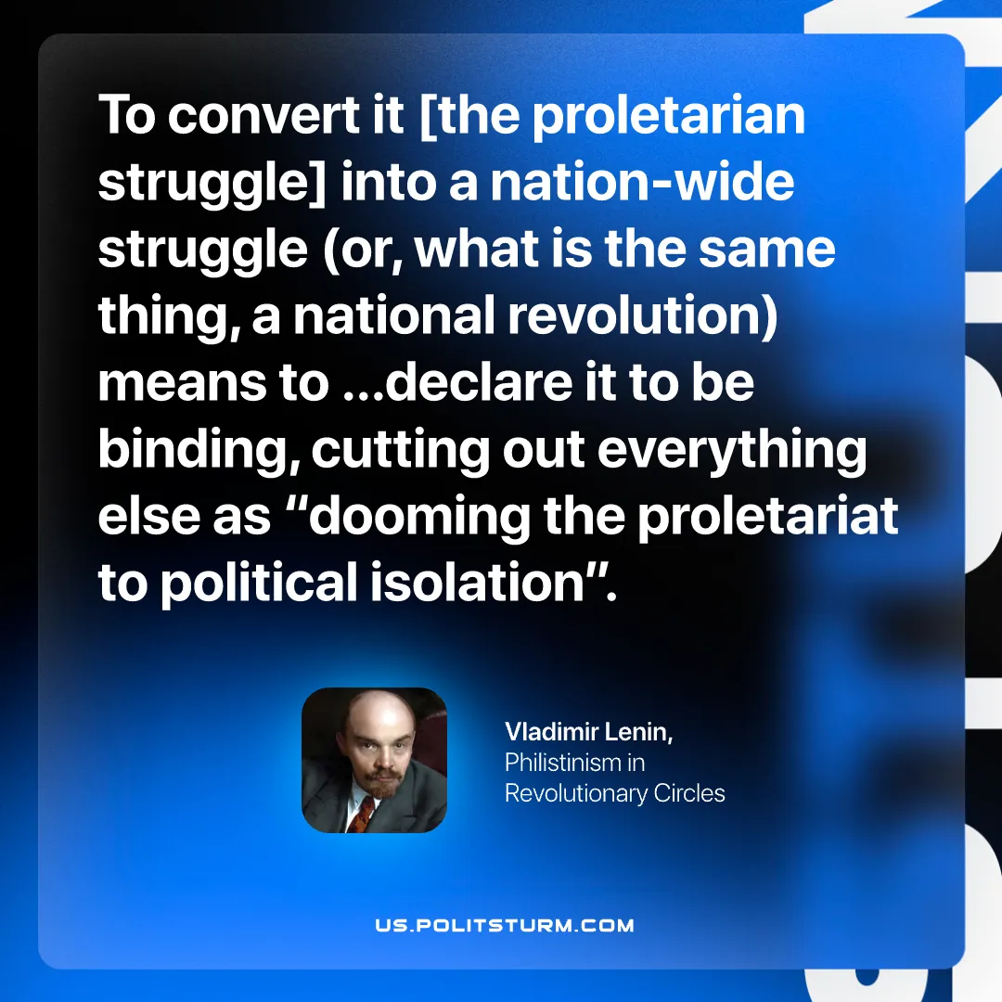

Original article
2025-12-25

To convert it [the proletarian struggle] into a nation-wide struggle (or, what is the same thing, a national revolution) means to …declare it to be binding, cutting out everything else as “dooming the proletariat to political isolation”.”
Vladimir Lenin, Philistinism in Revolutionary Circles

Original article

