Lenin on the Contradictory Nature of a Capitalist Republic
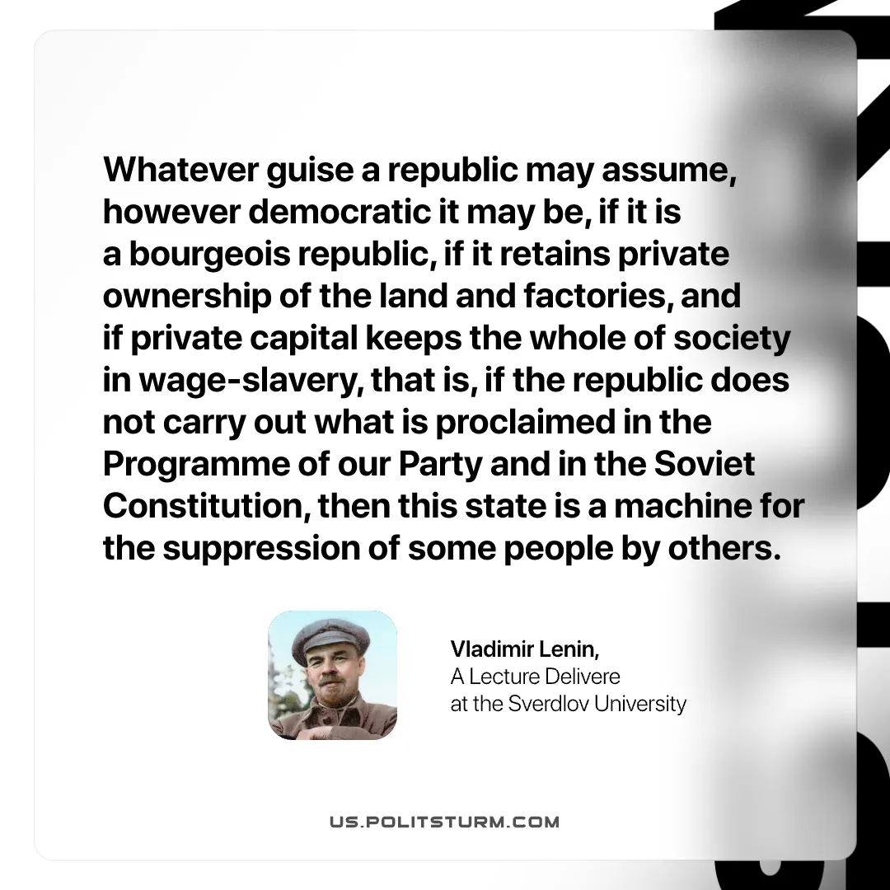

Original article
2026-02-22
1 min read

“Whatever guise a republic may assume, however democratic it may be, if it is a bourgeois republic, if it retains private ownership of the land and factories, and if private capital keeps the whole of society in wage-slavery, that is, if the republic does not carry out what is proclaimed in the Programme of our Party and in the Soviet Constitution, then this state is a machine for the suppression of some people by others.
Vladimir Lenin, A Lecture Delivered at the Sverdlov University

Original article

