Lenin on the Content of Opportunism and Social-Chauvinism
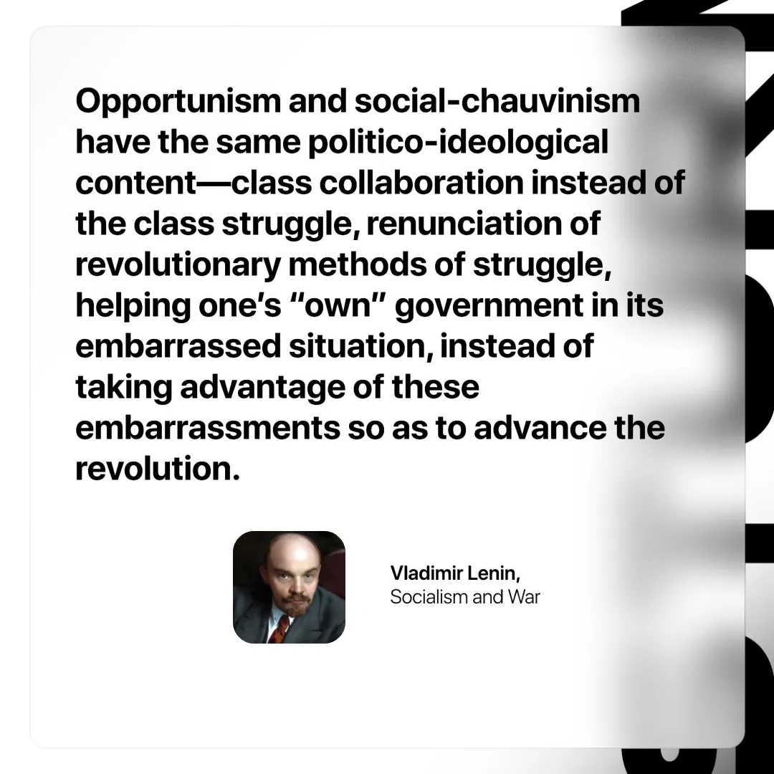

Original article
2025-03-18

​"Opportunism and social-chauvinism have the same politico-ideological content—class collaboration instead of the class struggle, renunciation of revolutionary methods of struggle, helping one’s “own” government in its embarrassed situation, instead of taking advantage of these embarrassments so as to advance the revolution."
Vladimir Lenin, Socialism and War

Original article

