Lenin on the Conditions for the Tasks of a Vanguard
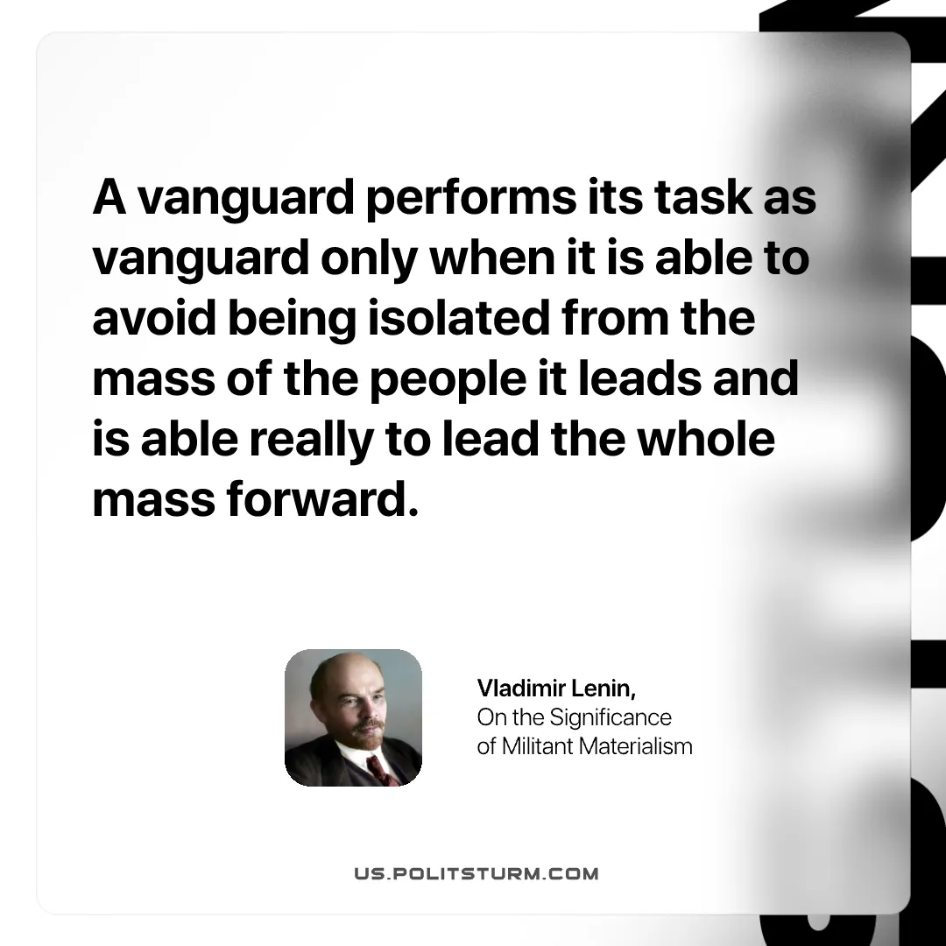

Original article
2025-08-31

“A vanguard performs its task as vanguard only when it is able to avoid being isolated from the mass of the people it leads and is able really to lead the whole mass forward.”
Vladimir Lenin, On the Significance of Militant Materialism

Original article

