Lenin on the Class Struggle
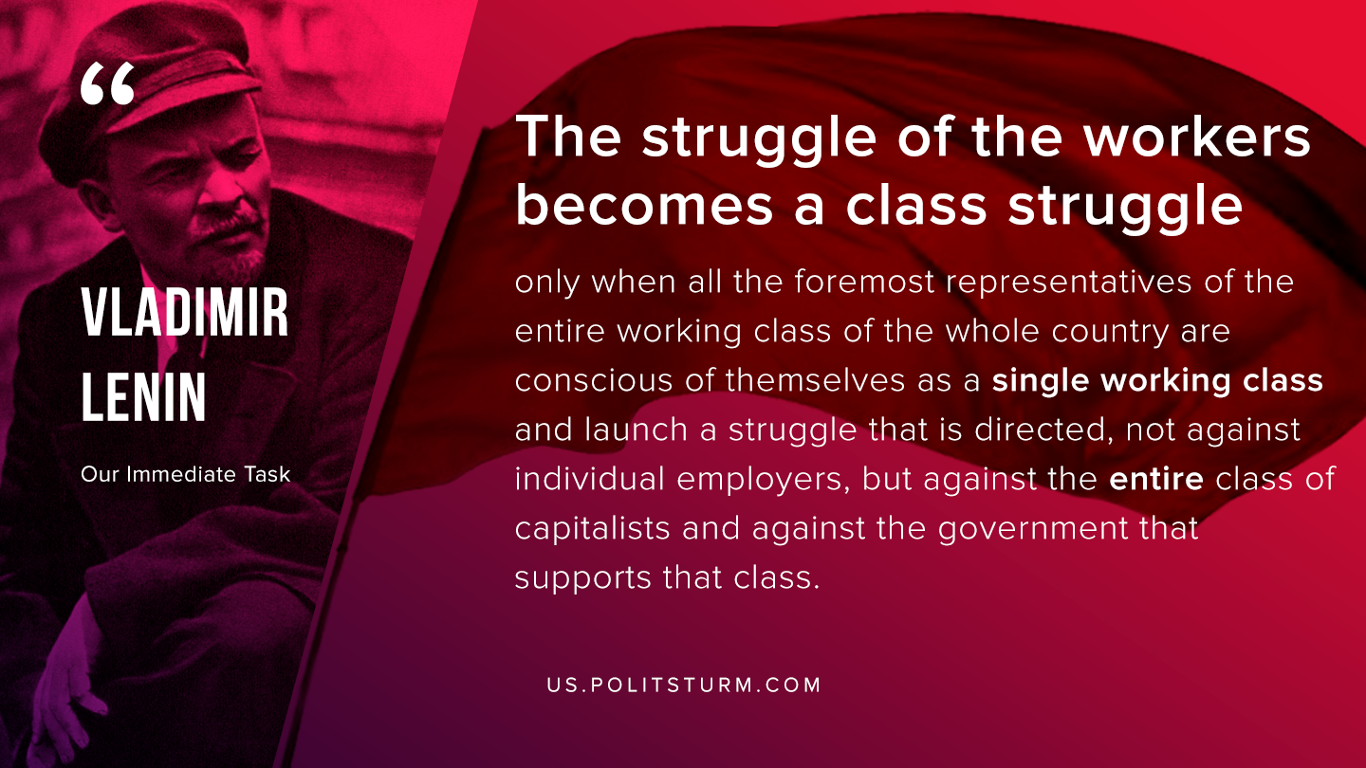

Original article
2020-05-07

The struggle of the workers becomes a class struggle only when all the foremost representatives of the entire working class of the whole country are conscious of themselves as a single working class and launch a struggle that is directed, not against individual employers, but against the entire class of capitalists and against the government that supports that class.
V.I. Lenin, “Our Immediate Task”

Original article

