Lenin on the Class Enemy of Social-Chauvinism
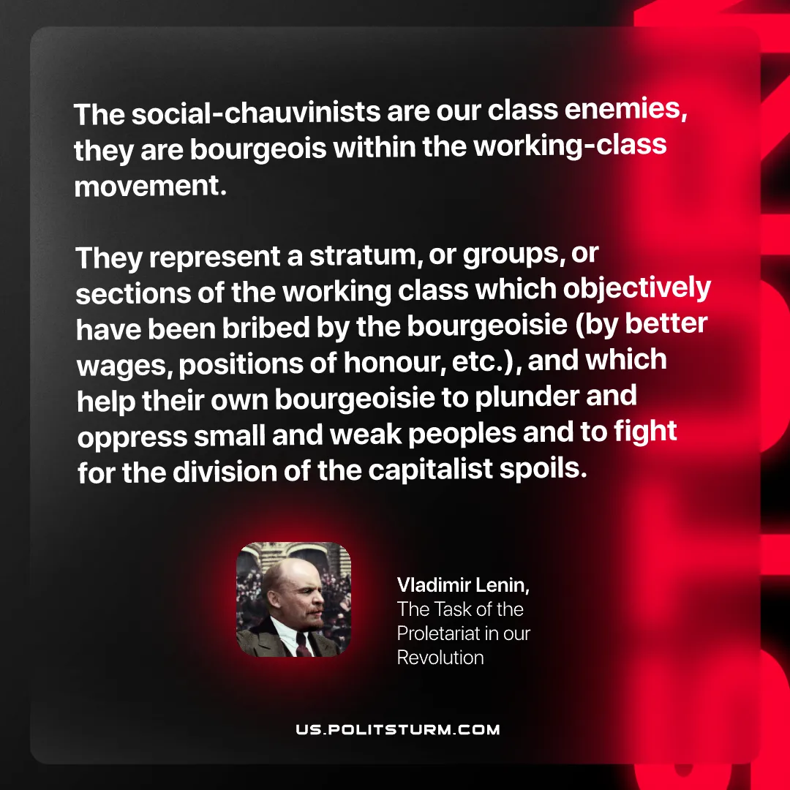

Original article
2025-08-14

“The social-chauvinists are our class enemies, they are bourgeois within the working-class movement. They represent a stratum, or groups, or sections of the working class which objectively have been bribed by the bourgeoisie (by better wages, positions of honour, etc.), and which help their own bourgeoisie to plunder and oppress small and weak peoples and to fight for the division of the capitalist spoils.”
Vladimir Lenin, The Task of the Proletariat in our Revolution

Original article

