Lenin on the Class-Conscious Worker
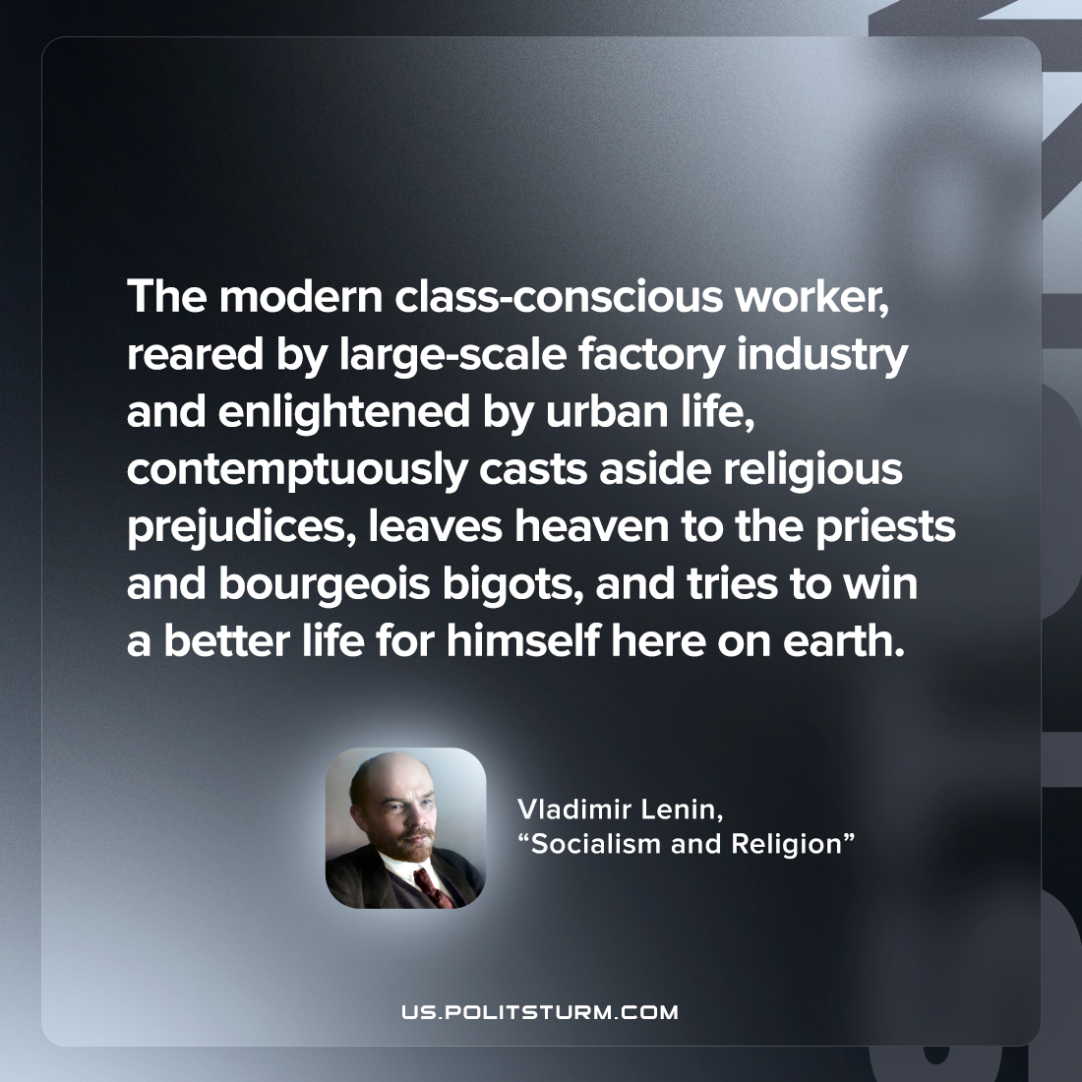

Original article
2022-07-25

The modern class-conscious worker, reared by large-scale factory industry and enlightened by urban life, contemptuously casts aside religious prejudices, leaves heaven to the priests and bourgeois bigots, and tries to win a better life for himself here on earth.

Vladimir Lenin, “Socialism and religion”

Original article

