Lenin on the Clarity Provided by the Marxist Line
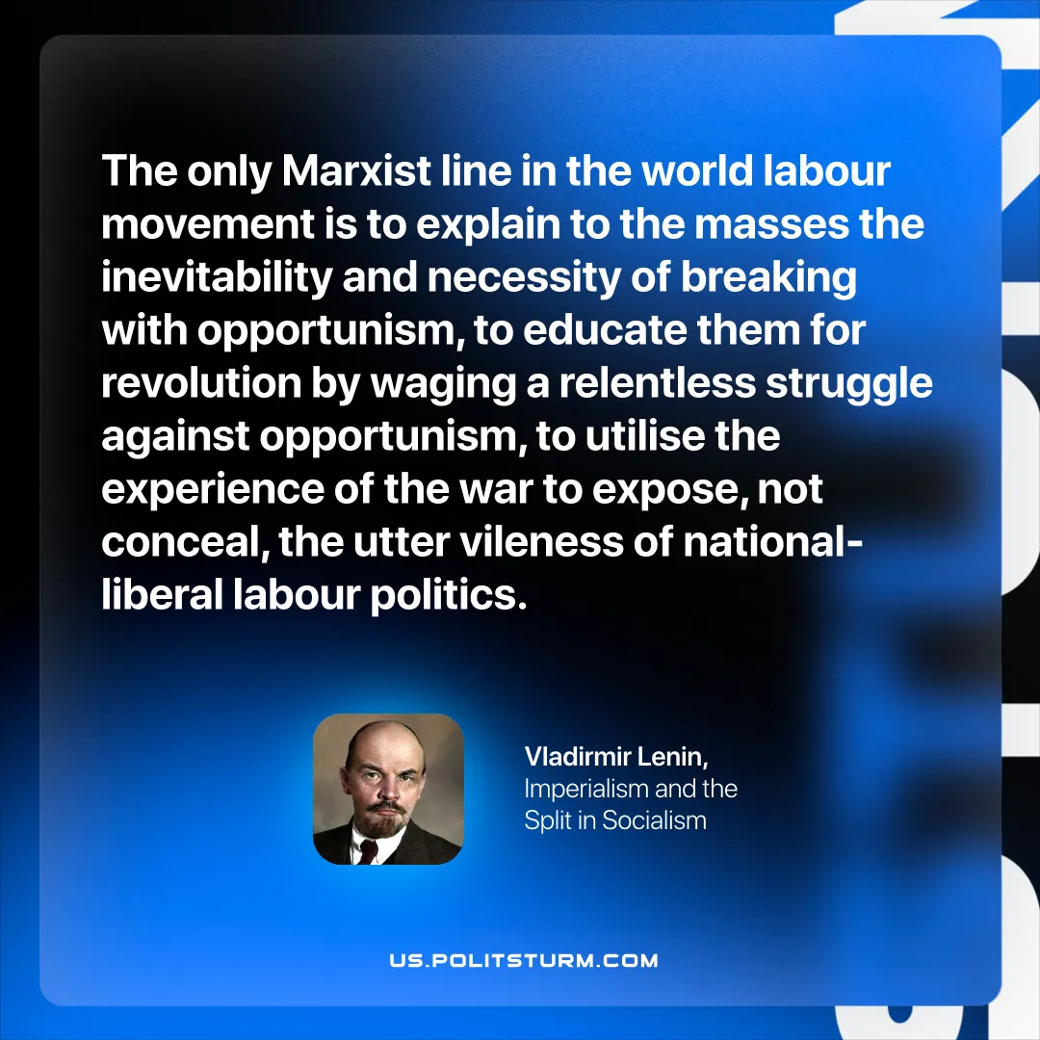

Original article
2025-10-23

“The only Marxist line in the world labour movement is to explain to the masses the inevitability and necessity of breaking with opportunism, to educate them for revolution by waging a relentless struggle against opportunism, to utilise the experience of the war to expose, not conceal, the utter vileness of national-liberal labour politics.”
Vladimir Lenin, Imperialism and the Split in Socialism

Original article

