Lenin on the Cause of the Revolution
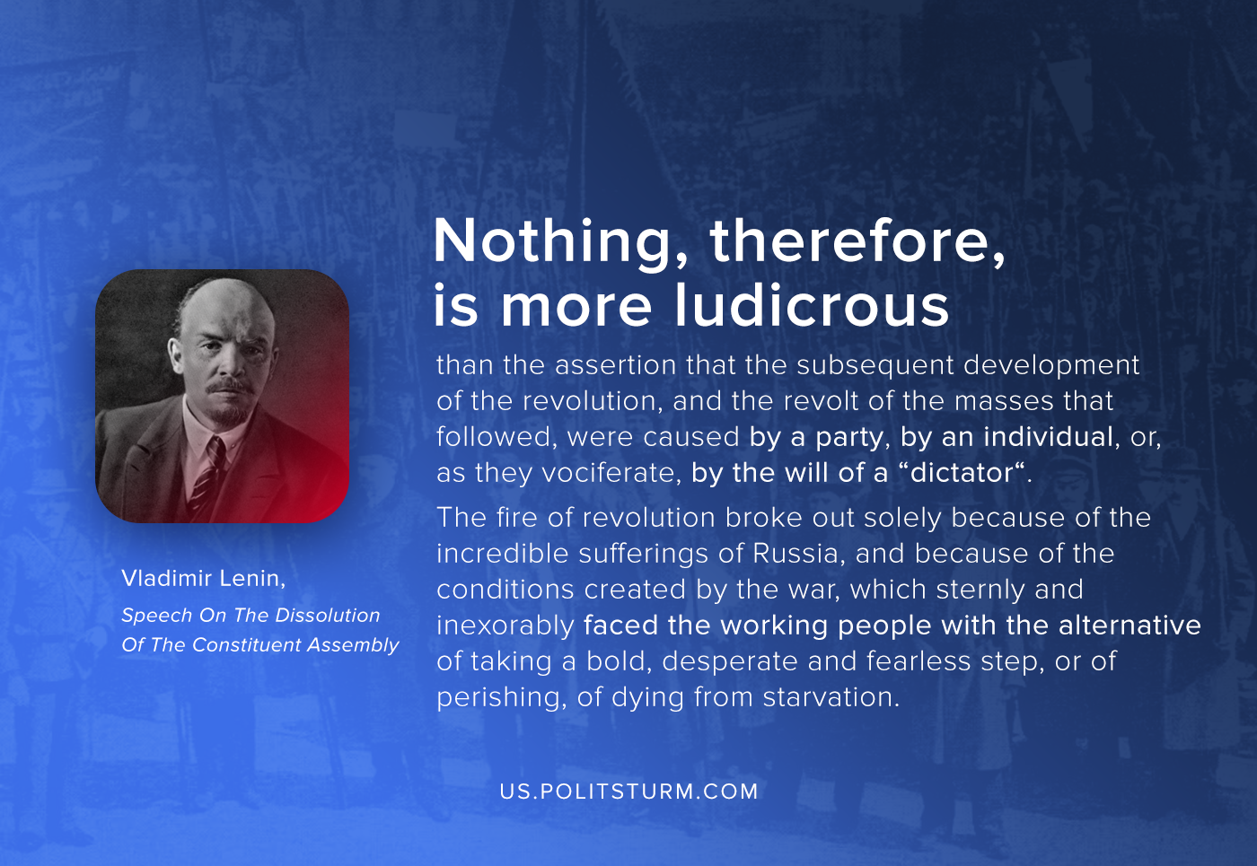

Original article
2020-07-18
1 min read

Nothing, therefore, is more ludicrous than the assertion that the subsequent development of the revolution, and the revolt of the masses that followed, were caused by a party, by an individual, or, as they vociferate, by the will of a “dictator“.
The fire of revolution broke out solely because of the incredible sufferings of Russia, and because of the conditions created by the war, which sternly and inexorably faced the working people with the alternative of taking a bold, desperate and fearless step, or of perishing, of dying from starvation.
Vladimir Lenin, “Speech On The Dissolution Of The Constituent Assembly”

Original article

