Lenin on the Capabilities of the Workers in Times of Revolution
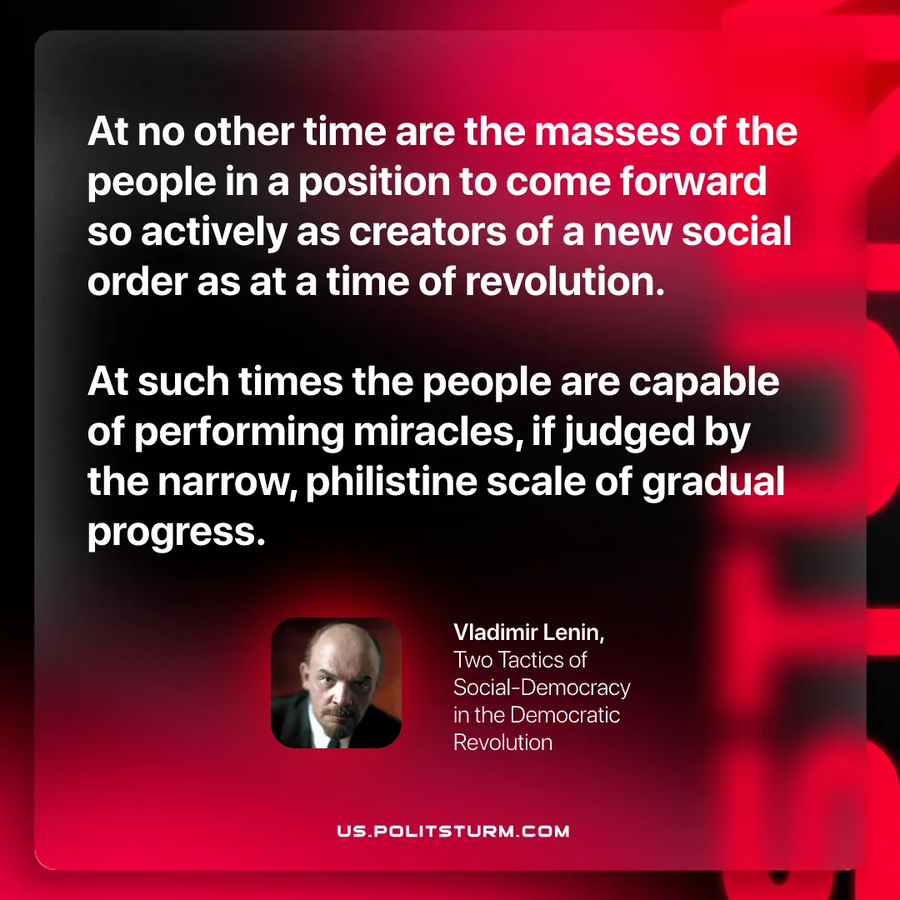

Original article
2026-03-14

“At no other time are the masses of the people in a position to come forward so actively as creators of a new social order as at a time of revolution. At such times the people are capable of performing miracles, if judged by the narrow, philistine scale of gradual progress.”
Vladimir Lenin, Two Tactics of Social-Democracy in the Democratic Revolution

Original article

