Lenin on the Bourgeoisie Death throes
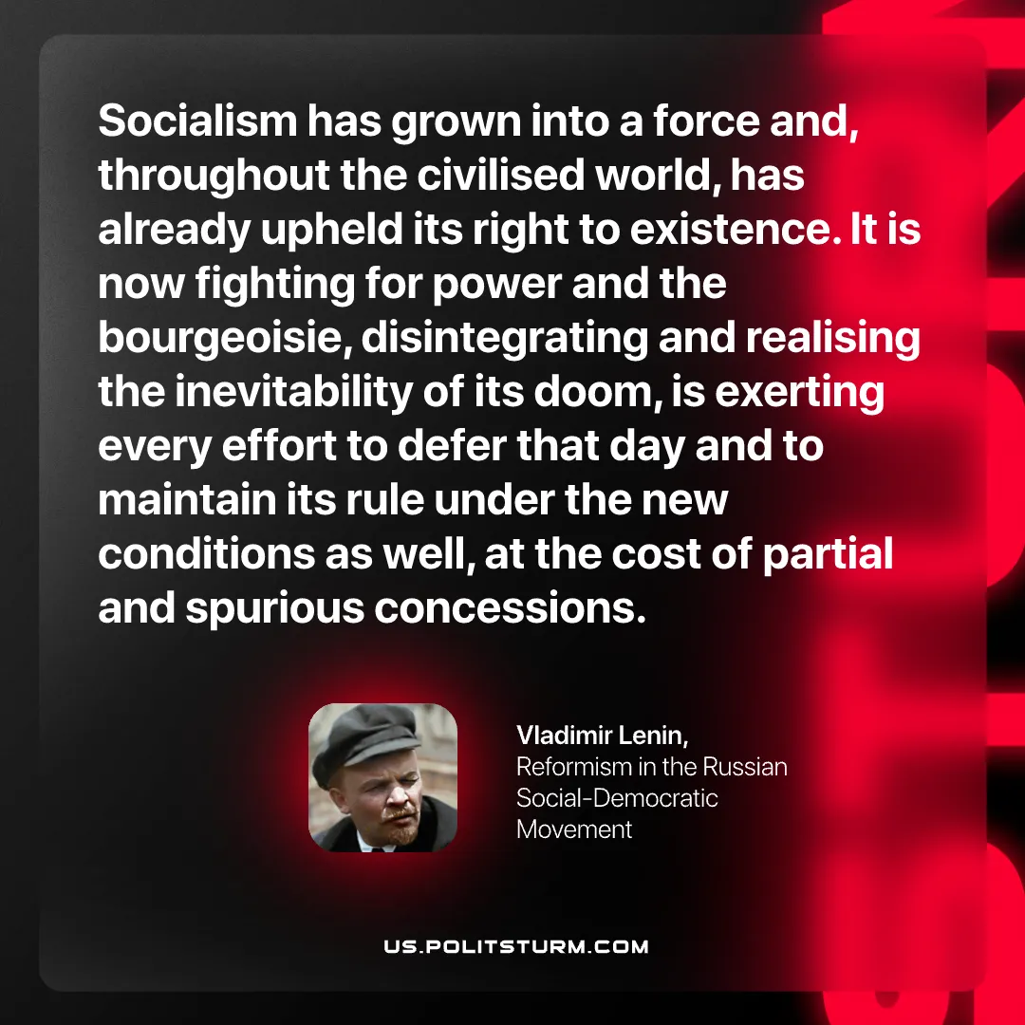

Original article
2026-10-10

Socialism has grown into a force and, throughout the civilised world, has already upheld its right to existence. It is now fighting for power and the bourgeoisie, disintegrating and realising the inevitability of its doom, is exerting every effort to defer that day and to maintain its rule under the new conditions as well, at the cost of partial and spurious concessions.
Vladimir Lenin, Reformism in the Russian Social-Democratic Movement

Original article

