Lenin on the Bourgeois Reaction
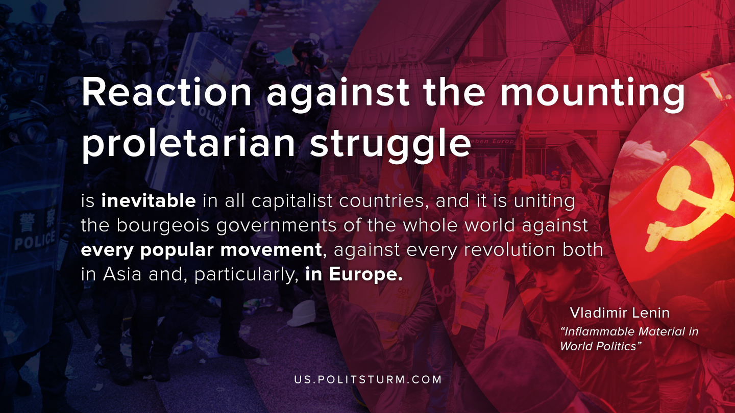

Original article
2020-03-20

Reaction against the mounting proletarian struggle is inevitable in all capitalist countries, and it is uniting the bourgeois governments of the whole world against every popular movement, against every revolution both in Asia and, particularly, in Europe.
Vladimir Lenin, “Inflammable Material in World Politics”

Original article

