Lenin on the Bourgeois Press
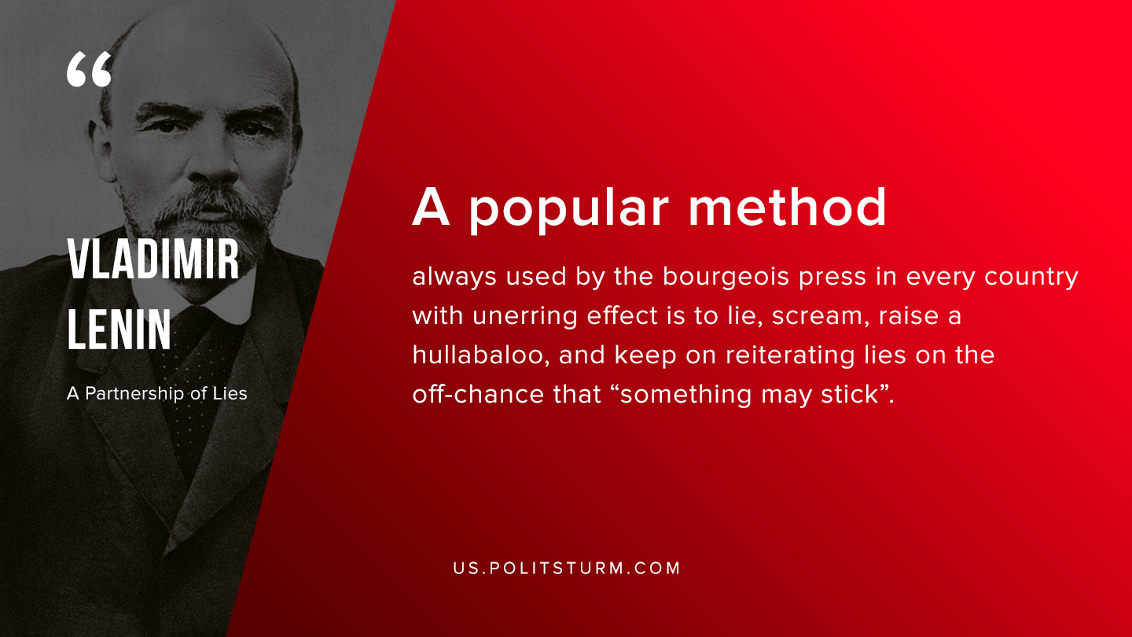

Original article
2019-08-28

A popular method always used by the bourgeois press in every country with unerring effect is to lie, scream, raise a hullabaloo, and keep on reiterating lies on the off-chance that “something may stick”.
Vladimir Lenin, “A Partnership of Lies”

Original article

