Lenin on the Bourgeois Pacifism
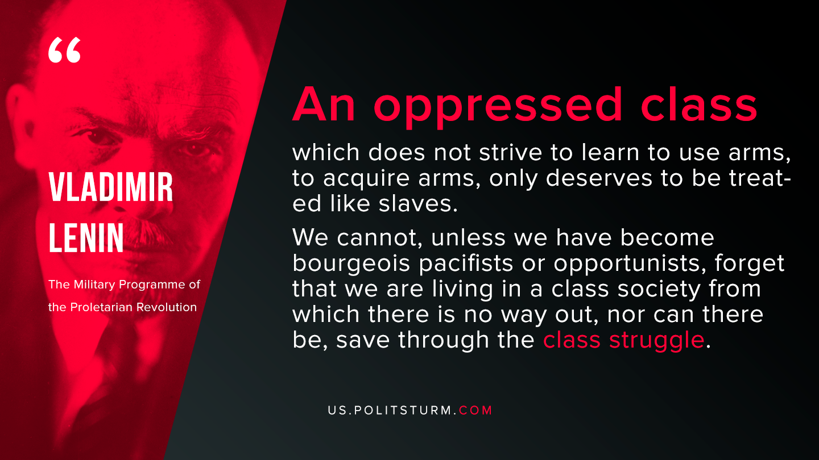

Original article
2019-11-16

An oppressed class which does not strive to learn to use arms, to acquire arms, only deserves to be treated like slaves. We cannot, unless we have become bourgeois pacifists or opportunists, forget that we are living in a class society from which there is no way out, nor can there be, save through the class struggle.
V.I. Lenin, “The military Programme of the Proletarian Revolution”

Original article

