Lenin on the Bourgeois Elections
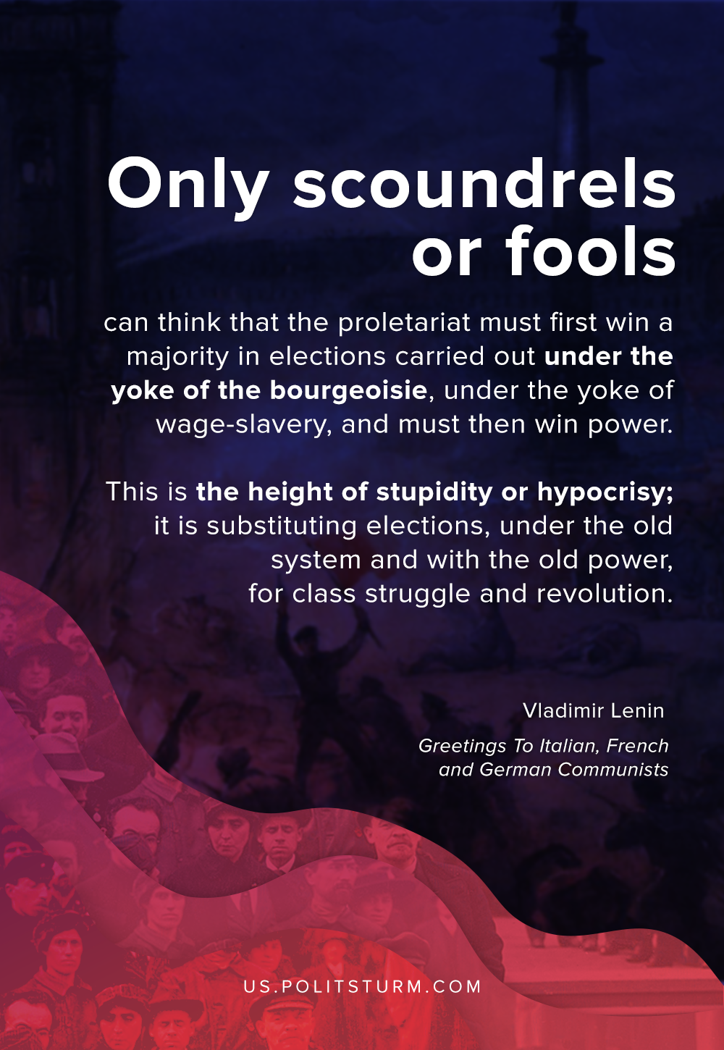

Original article
2020-09-07

Only scoundrels or fools can think that the proletariat must first win a majority in elections carried out under the yoke of the bourgeoisie, under the yoke of wage-slavery, and must then win power. This is the height of stupidity or hypocrisy; it is substituting elections, under the old system and with the old power, for class struggle and revolution.
V. I. Lenin. Greetings To Italian, French and German Communists.

Original article

