Lenin on the Arms Trade
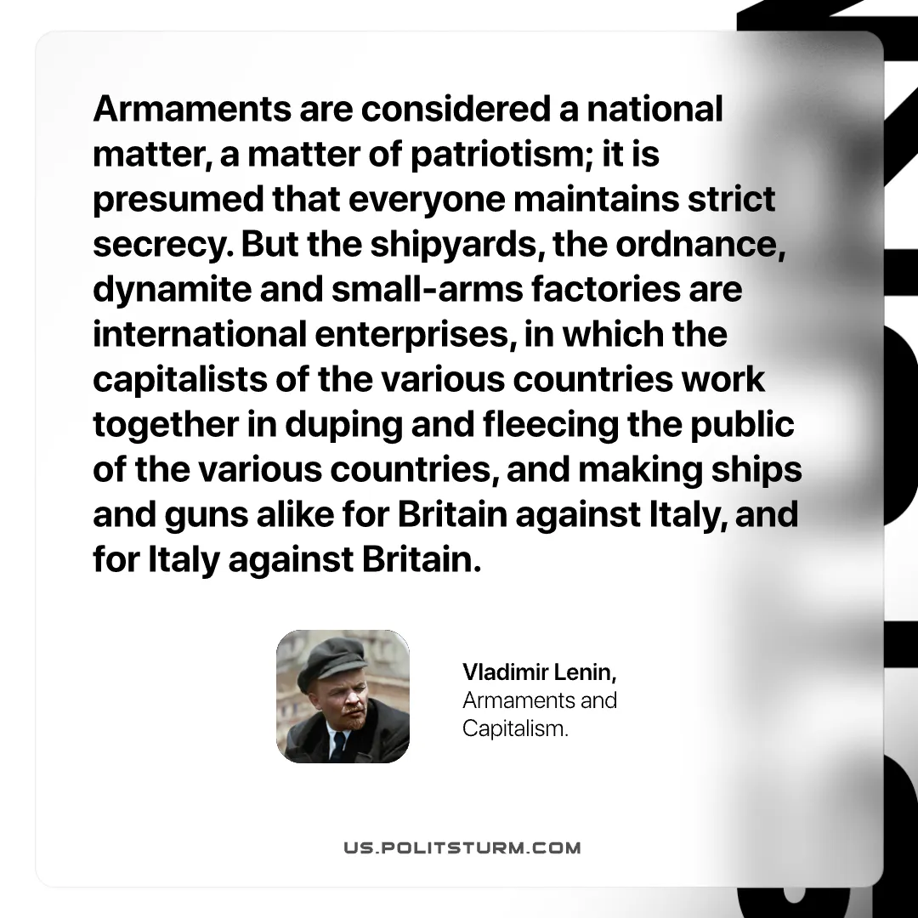

Original article
2026-06-13

Armaments are considered a national matter, a matter of patriotism; it is presumed that everyone maintains strict secrecy. But the shipyards, the ordnance, dynamite and small‑arms factories are international enterprises, in which the capitalists of the various countries work together in duping and fleeing the public of the various countries, and making ships and guns alike for Britain against Italy, and for Italy against Britain.
Vladimir Lenin, Armaments and Capitalism.

Original article

