Lenin on the Armaments Race Disguised With Patriotism
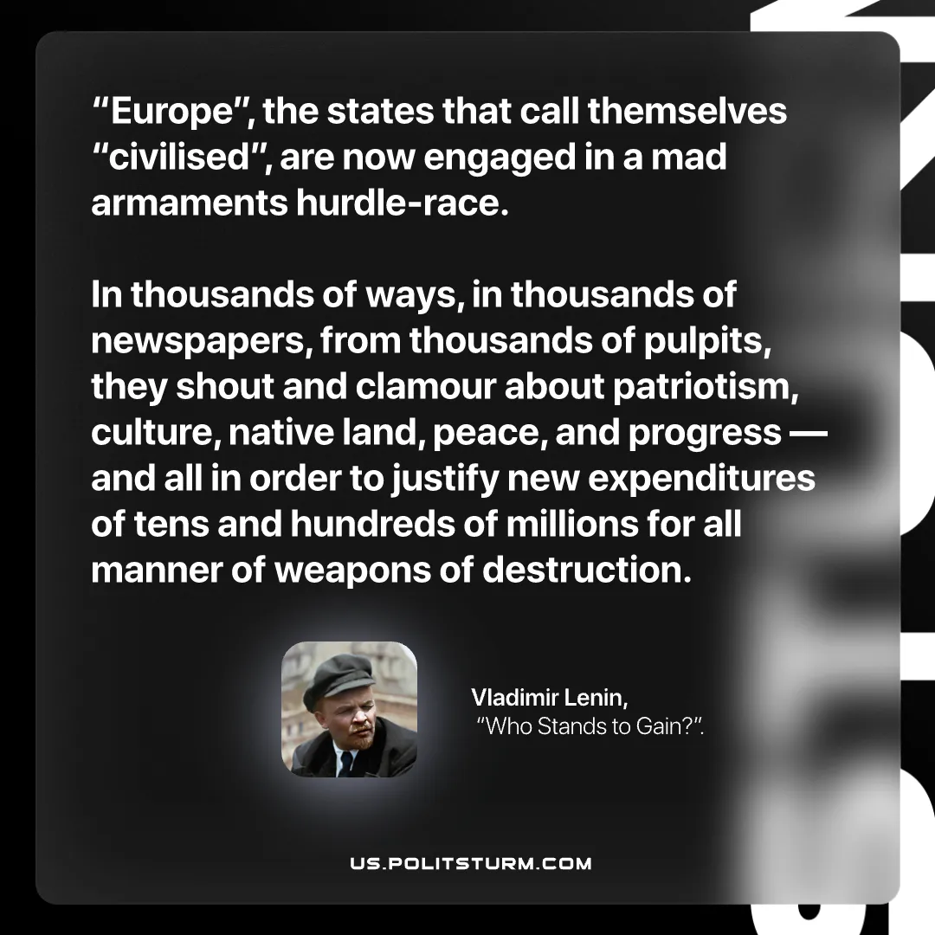

Original article
2026-07-05

"Europe", the states that call themselves "civilised", are now engaged in a mad armaments hurdle‑race. In thousands of ways, in thousands of newspapers, from thousands of pulpits, they shout and clamour about patriotism, culture, native land, peace, and progress — and all in order to justify new expenditures of tens and hundreds of millions for all manner of weapons of destruction.
Vladimir Lenin, “Who Stands to Gain?”

Original article

