Lenin on the Alliance of Opportunists With Capitalists
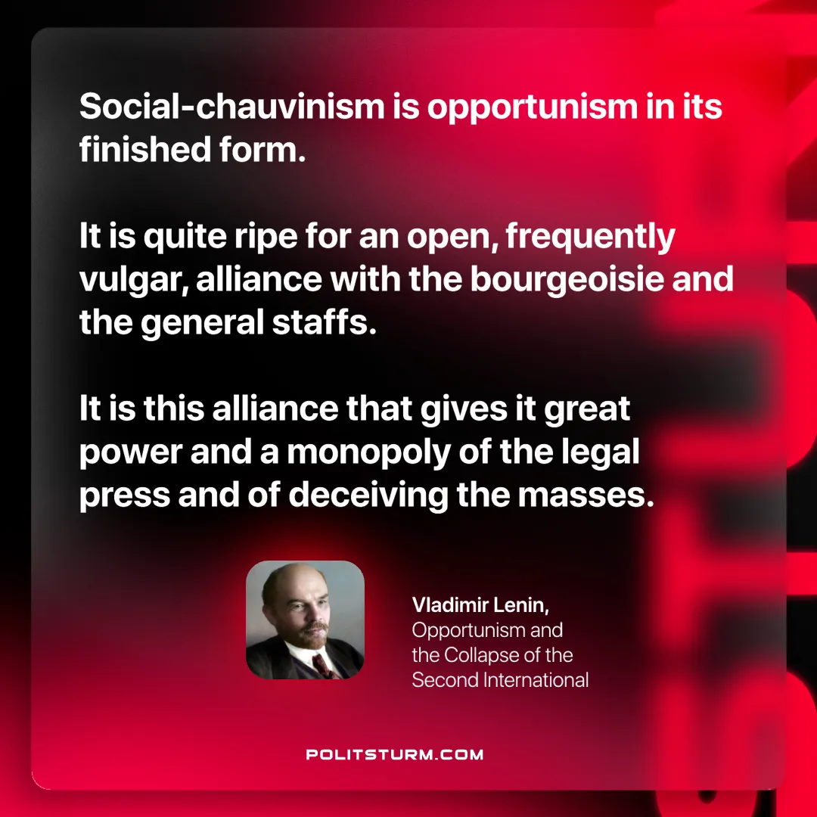

Original article
2025-05-20

“Social-chauvinism is opportunism in its finished form. It is quite ripe for an open, frequently vulgar, alliance with the bourgeoisie and the general staffs. It is this alliance that gives it great power and a monopoly of the legal press and of deceiving the masses. It is absurd to go on regarding opportunism as an inner-party phenomenon.”
Vladimir Lenin, Opportunism and the Collapse of the Second International

Original article

