Lenin on Task Worthy of a Revolutionary
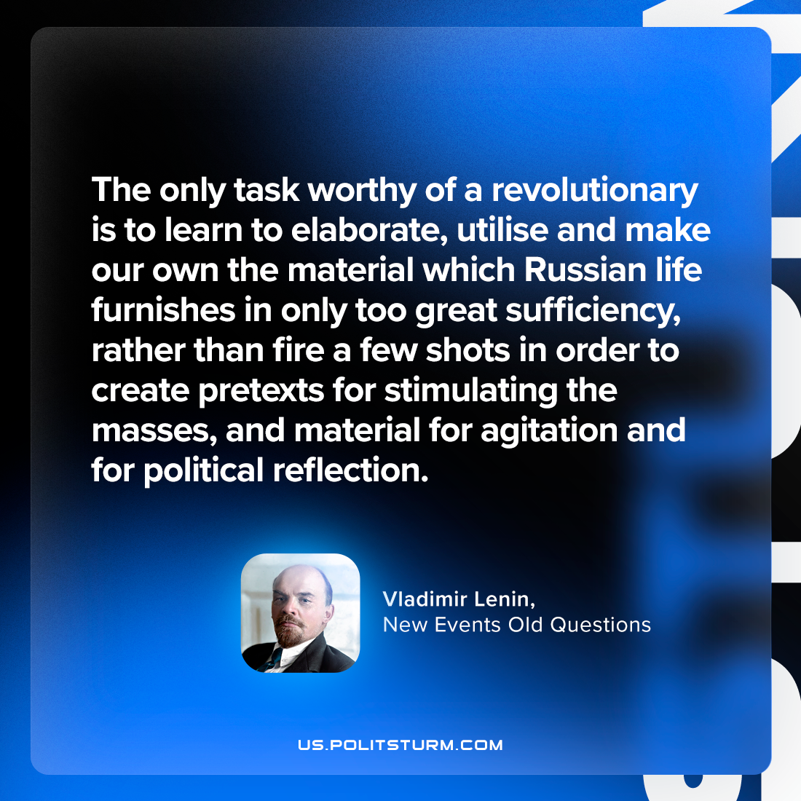

Original article
2023-08-05

"The only task worthy of a revolutionary is to learn to elaborate, utilise and make our own the material which Russian life furnishes in only too great sufficiency, rather than fire a few shots in order to create pretexts for stimulating the masses, and material for agitation and for political reflection."
Vladimir Lenin, New Events Old Questions

Original article

