Lenin on Studying History
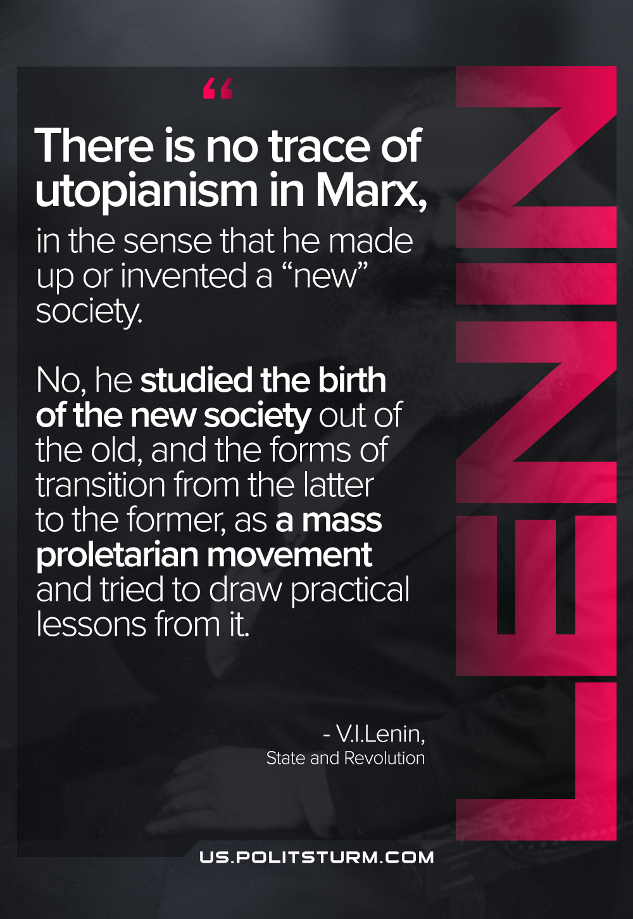

Original article
2021-06-13

There is no trace of utopianism in Marx, in the sense that he made up or invented a “new” society. No, he studied the birth of the new society out of the old, and the forms of transition from the latter to the former, as a mass proletarian movement and tried to draw practical lessons from it.
Vladimir Lenin, The State and Revolution

Original article

