Lenin on Struggle
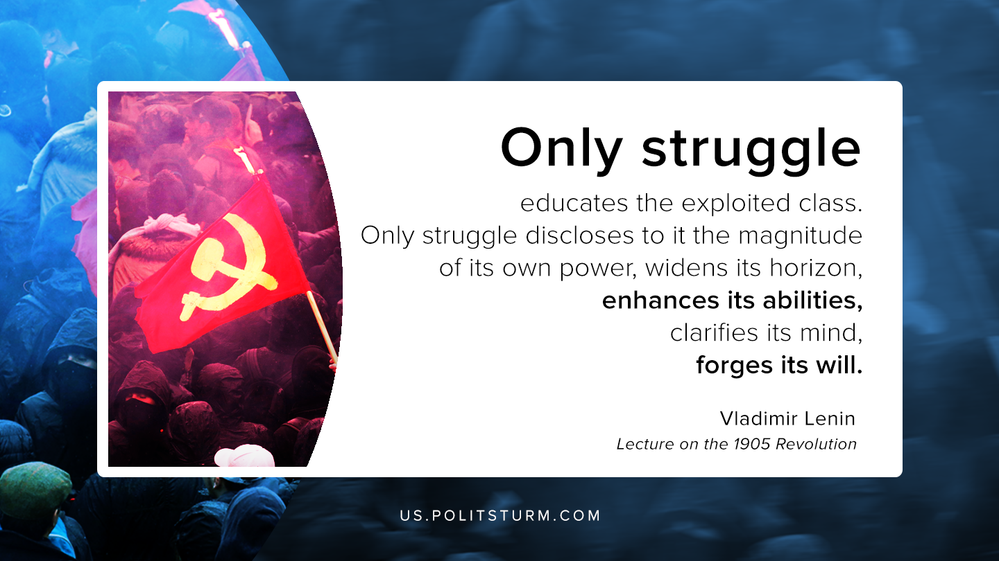

Original article
2020-08-17

Only struggle educates the exploited class. Only struggle discloses to it the magnitude of its own power, widens its horizon, enhances its abilities, clarifies its mind, forges its will.
Lenin, “Lecture on the 1905 Revolution”

Original article

