Lenin on Struggle Against Bourgeois Influence
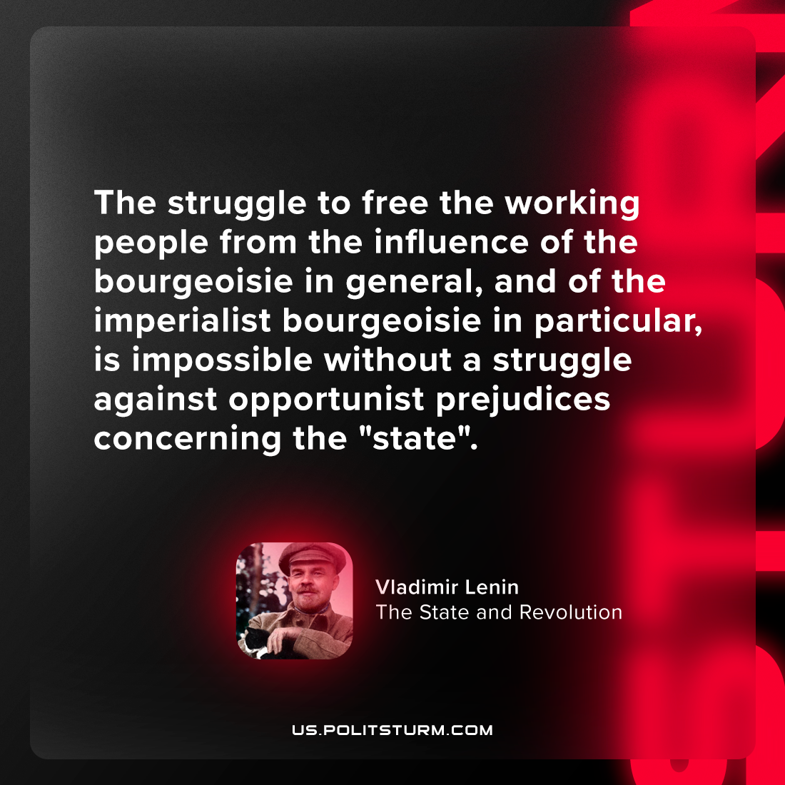

Original article
2024-02-14

"The struggle to free the working people from influence of the bourgeoisie in general, and the imperialist bourgeoisie in particular, is impossible without a struggle against opportunist prejudices concerning the "state"
Vladimir Lenin, The State and Revolution

Original article

