Lenin on Strikes
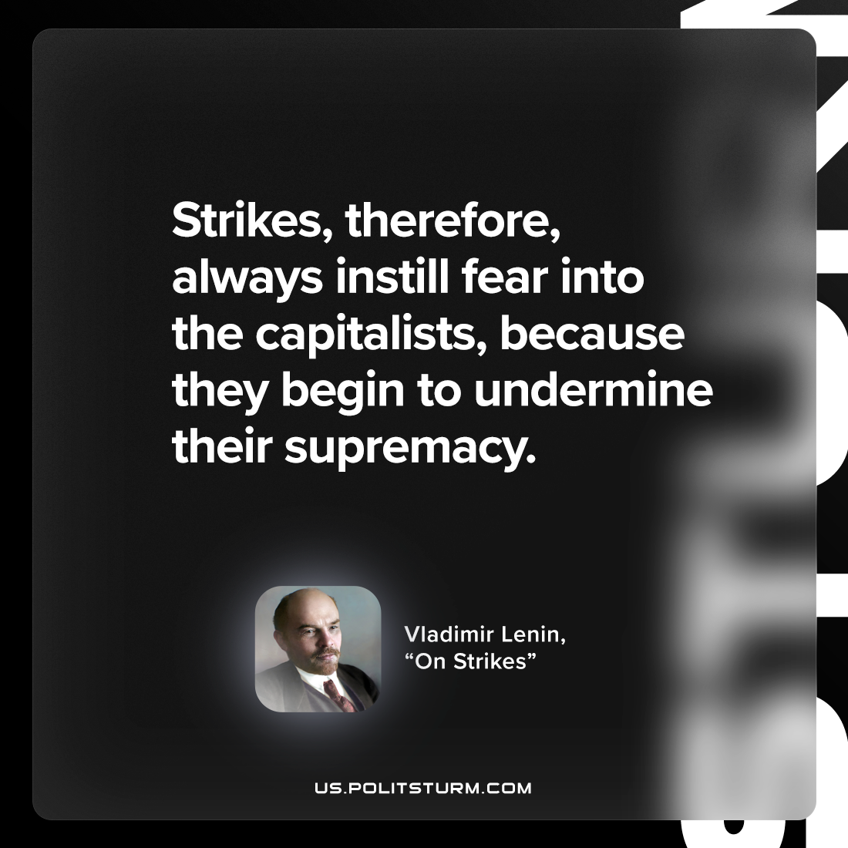

Original article
2023-01-01

"Strikes, therefore, always instill fear into the capitalists, because they begin to undermine their supremacy."
Vladimir Lenin, ”On Strikes”

Original article

