Lenin on Strikes
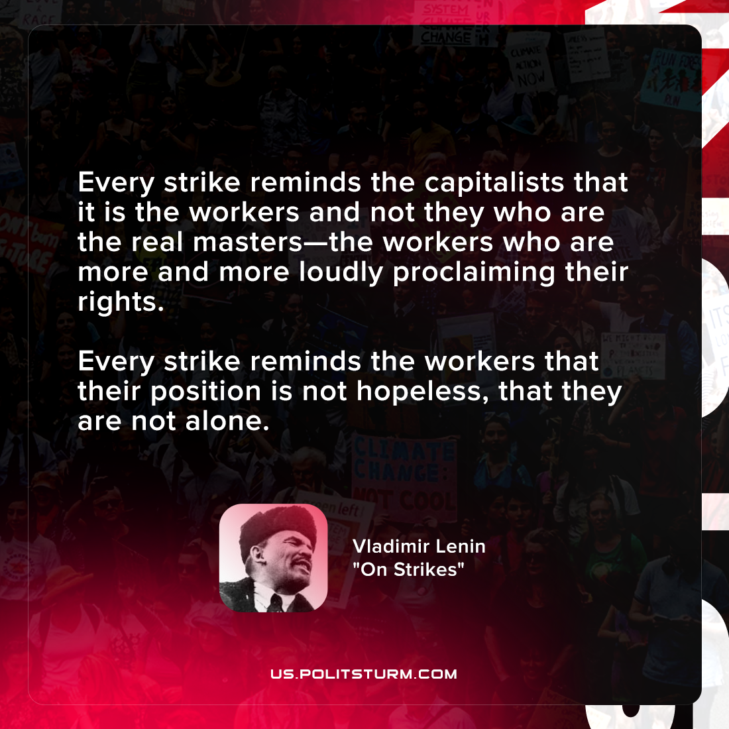

Original article
2021-10-15

Every strike reminds the capitalists that it is the workers and not they who are the real masters—the workers who are more and more loudly proclaiming their rights. Every strike reminds the workers that their position is not hopeless, that they are not alone.

Vladimir Lenin, “On Strikes”

Original article

