Lenin on Strikes
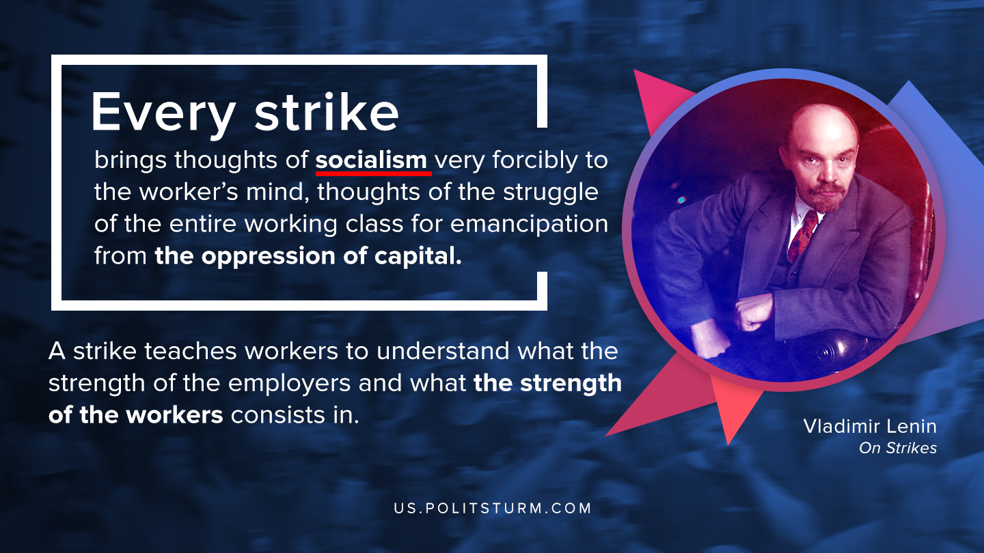

Original article
2020-08-28

Every strike brings thoughts of socialism very forcibly to the worker’s mind, thoughts of the struggle of the entire working class for emancipation from the oppression of capital.
A strike teaches workers to understand what the strength of the employers and what the strength of the workers consists in; it teaches them not to think of their own employer alone, but of all the employers, the whole class of capitalists and the whole class of workers.
V.I.Lenin, On Strikes

Original article

