Lenin on Socialist Revolution
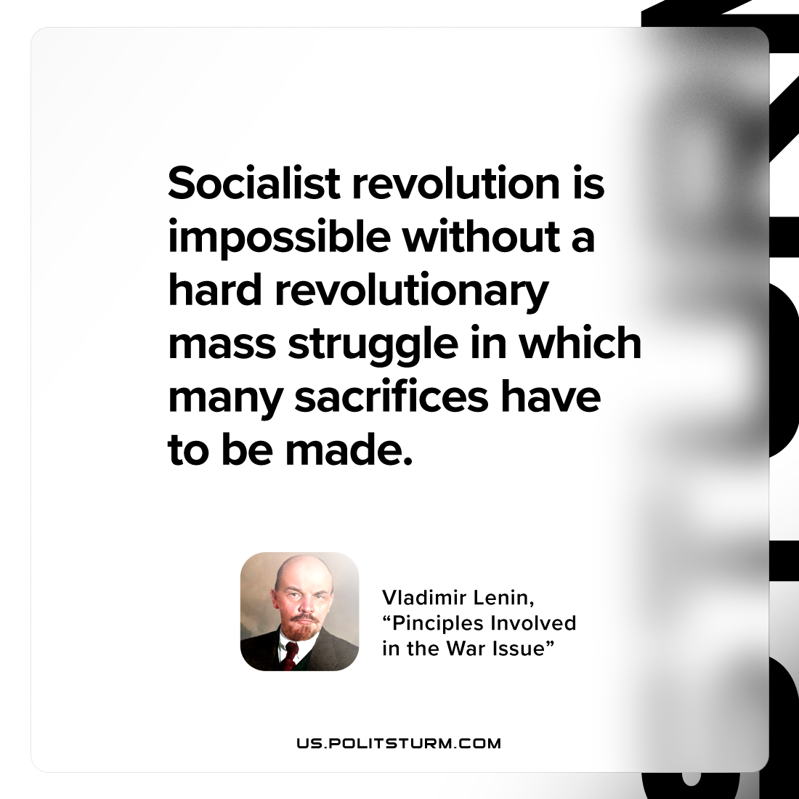

Original article
2023-03-28

"Socialist revolution is impossible without a hard revolutionary mass struggle in which many sacrifices have to be made."
Vladimir Lenin, “Principles Involved in the War Issue”

Original article

