Lenin on Socialism Applying Democracy and Self-Determination
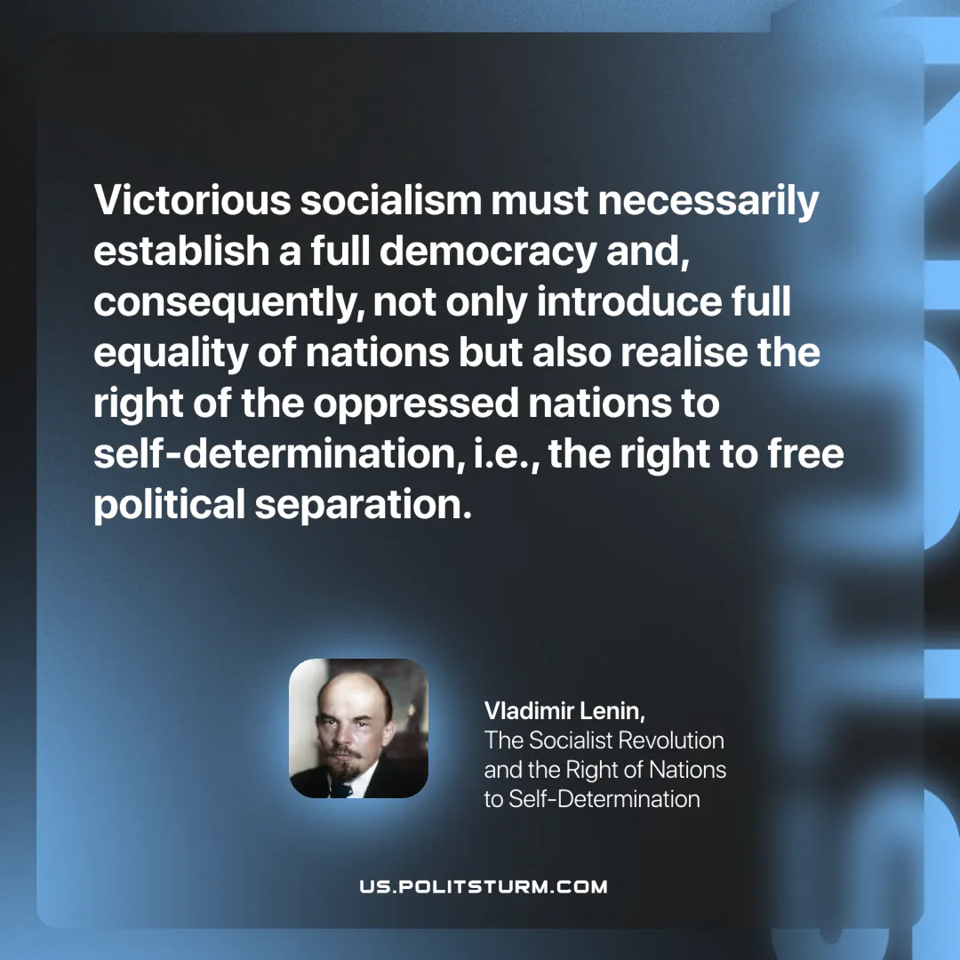

Original article
2025-07-15

"Victorious socialism must necessarily establish a full democracy and, consequently, not only introduce full equality of nations but also realise the right of the oppressed nations to self-determination, i.e., the right to free political separation."
Vladimir Lenin, The Socialist Revolution and the Right of Nations to Self-Determination

Original article

