Lenin on Socialism and Democracy
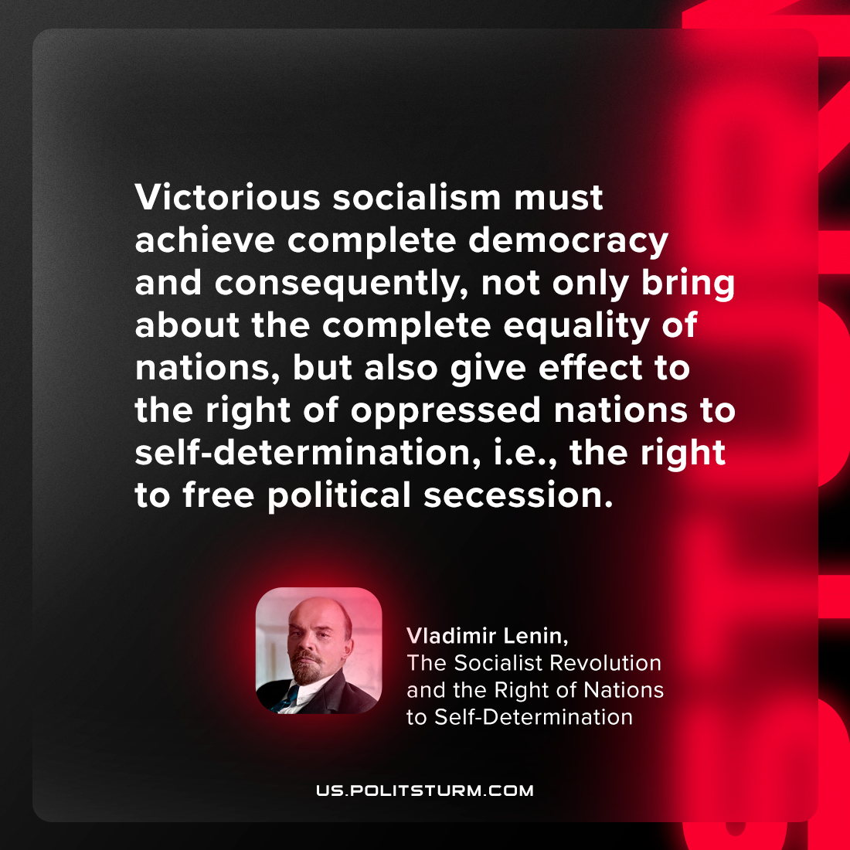

Original article
2024-03-24

“Victorious socialism must achieve complete democracy and, consequently, not only bring about the complete equality of nations, but also give effect to the right of oppressed nations to self-determination, i.e., the right to free political secession.”
Vladimir Lenin, The Socialist Revolution and the Right of Nations to Self-Determination

Original article

