Lenin on Social-Chauvinists
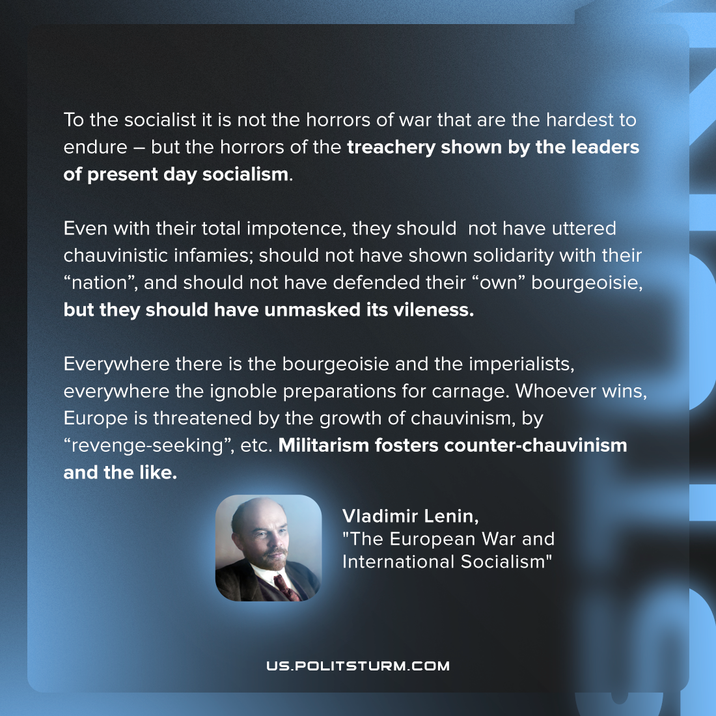

Original article
2022-07-01
1 min read

To the socialist it is not the horrors of war that are the hardest to endure – but the horrors of the treachery shown by the leaders of present day socialism. Even with their total impotence, they should not have uttered chauvinistic infamies; should not have shown solidarity with their “nation”, and should not have defended their “own” bourgeoisie, but they should have unmasked its vileness.
Everywhere there is the bourgeoisie and the imperialists, everywhere the ignoble preparations for carnage. Whoever wins, Europe is threatened by the growth of chauvinism, by “revenge-seeking”, etc. Militarism fosters counter-chauvinism and the like.
Vladimir Lenin, “The European War and International Socialism”

Original article

