Lenin on Social‑Chauvinism
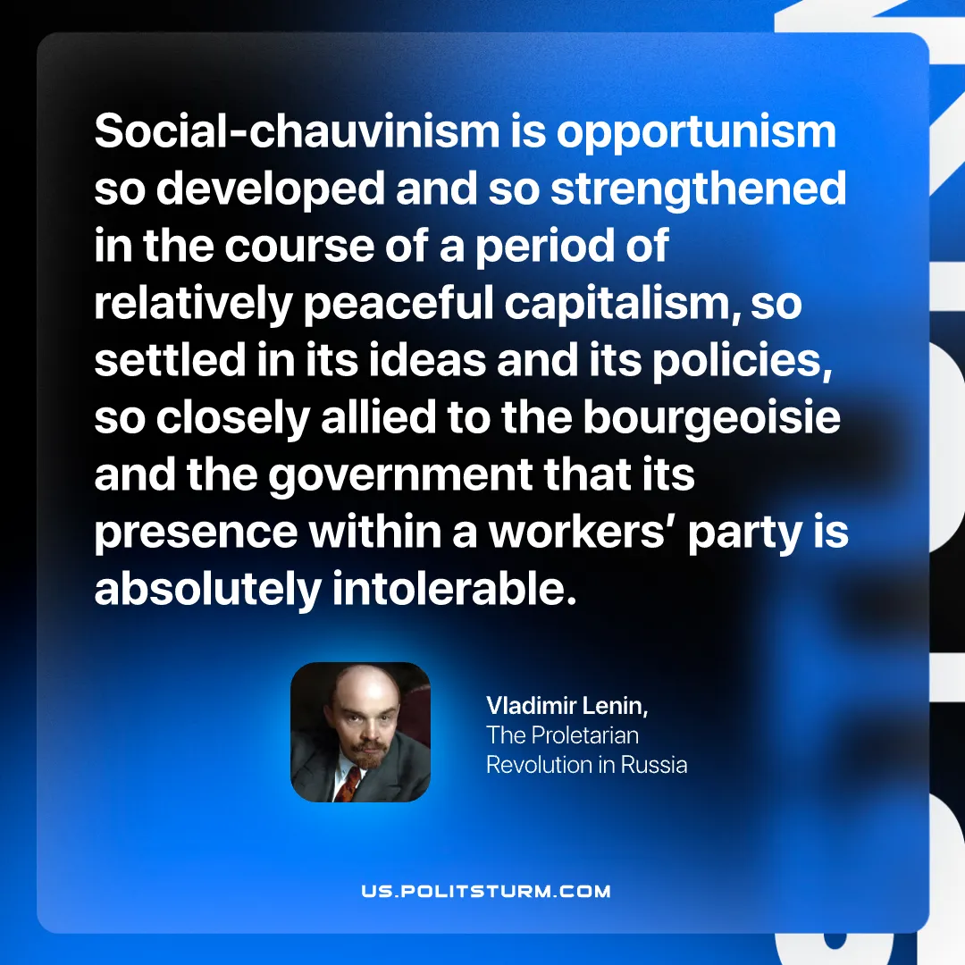

Original article
2026-06-16

Social‑chauvinism is opportunism so developed and so strengthened in the course of a period of relatively peaceful capitalism, so settled in its ideas and its policies, so closely allied to the bourgeoisie and the government that its presence within a workers’ party is absolutely intolerable.
Vladimir Lenin, The Proletarian Revolution in Russia

Original article

