Lenin on Social-Chauvinism
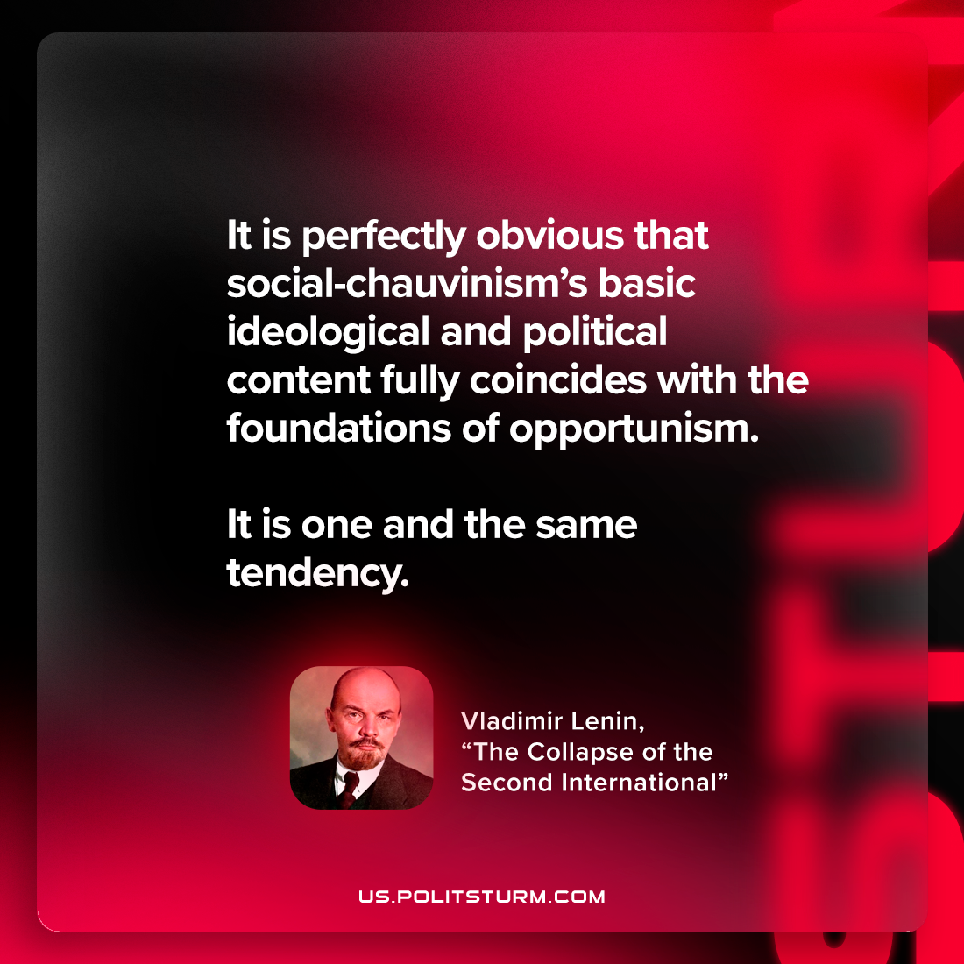

Original article
2022-12-01

"It is perfectly obvious that social-chauvinism’s basic ideological and political content fully coincides with the foundations of opportunism. It is one and the same tendency."
Vladimir Lenin, "The Collapse of the Second International"

Original article

