Lenin on the Revolutionary
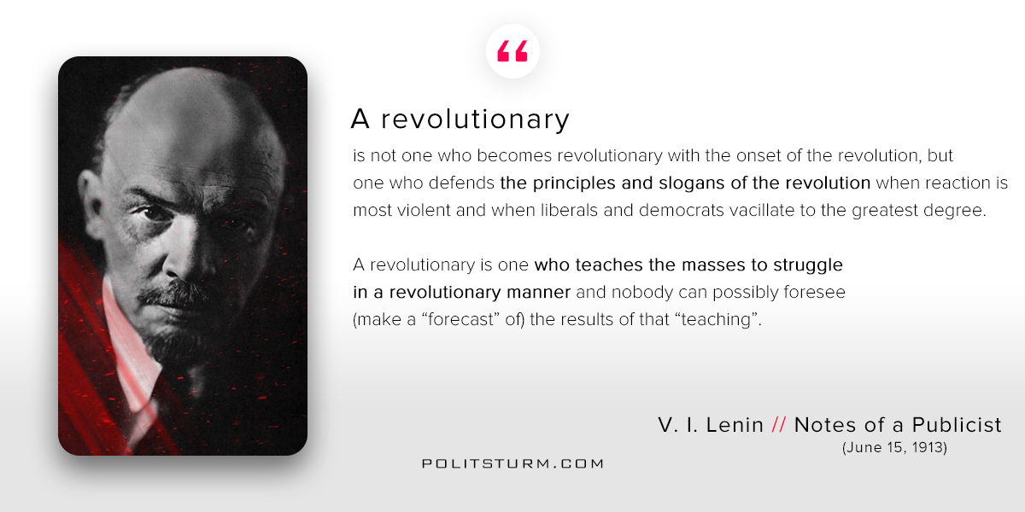

Original article
2018-03-06

“A revolutionary is not one who becomes revolutionary with the onset of the revolution, but one who defends the principles and slogans of the revolution when reaction is most violent and when liberals and democrats vacillate to the greatest degree.
A revolutionary is one who teaches the masses to struggle in a revolutionary manner and nobody can possibly foresee (make a “forecast” of) the results of that “teaching”.
V.I. Lenin “Notes of a Publicist”

Original article

